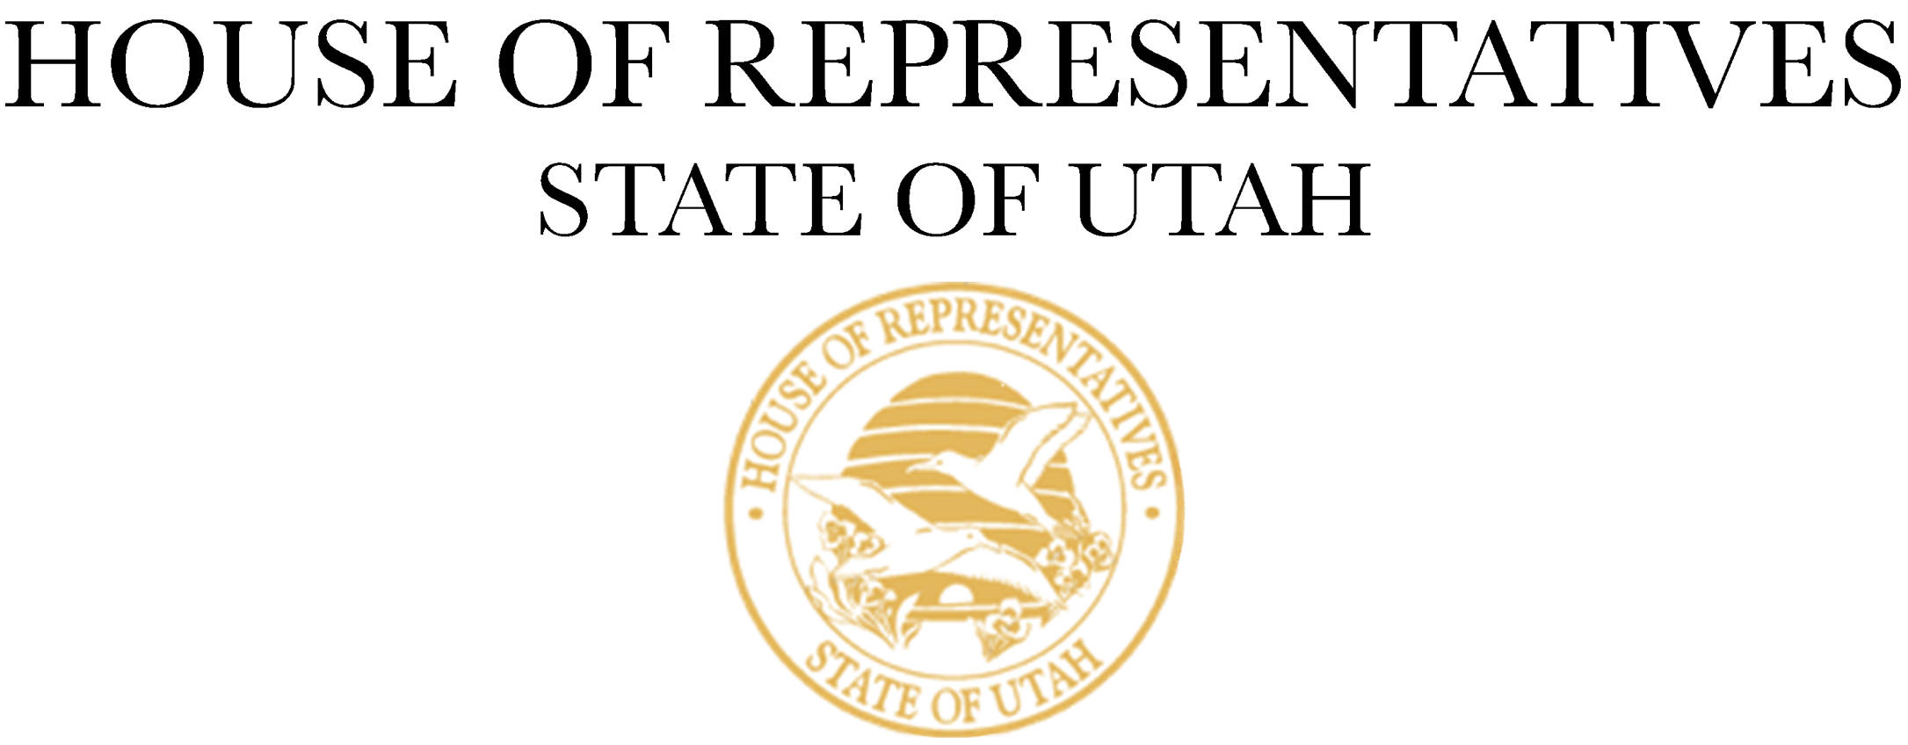

For Immediate Release
November 14, 2023

Contact:
Alexa Musselman
Utah House of Representatives
801-865-5882 | amusselman@le.utah.gov

Utah House Majority Caucus Elects New Speaker and Leadership Members

SALT LAKE CITY – The Utah House Majority Caucus held a special leadership election to replace Speaker Brad Wilson, who is resigning from the Utah State Legislature effective November 15, 2023. The following representatives have been elected to the respective positions for the remainder of the 2023-2024 term:

Speaker of the House – Mike Schultz
House Majority Leader – Jefferson Moss
House Majority Whip – Karianne Lisonbee
House Majority Assistant Whip – Casey Snider

The Utah House of Representatives will hold an extraordinary special session on November 15, 2023, at 5:00 p.m. in the House of Representatives Chamber to confirm Rep. Schultz as Speaker of the House.

“I am humbled to be chosen by my colleagues to serve as Speaker of the House,” said Rep. Schultz. This is a responsibility and a position that I take seriously, and I promise to give my all for my colleagues, for my community, and for Utah. Speaker Brad Wilson has been an exceptional Speaker and I am honored to follow in his footsteps. I appreciate his leadership and friendship and how he has led the body the past five years. As I step into the role of Speaker, I give my full commitment putting Utahns first.”

“I am thankful for the trust the Majority Caucus has placed in me,” said Rep. Moss. I’m committed to serving the members of our caucus and the people of Utah with diligence and integrity and look forward to accomplishing big things together.”

“It is an honor to serve as the Majority Whip,” said Rep. Lisonbee. “I’m excited to work alongside a great leadership team and an extraordinary caucus. The House Majority is ready to make big strides as we work to better the lives of Utahns.”

“Serving as the Majority Assistant Whip is an opportunity that I don’t take lightly,” said Rep. Snider. “I am honored to receive the support of my colleagues and look forward to serving them and representing their voices and the voices of all Utahns.”

###

