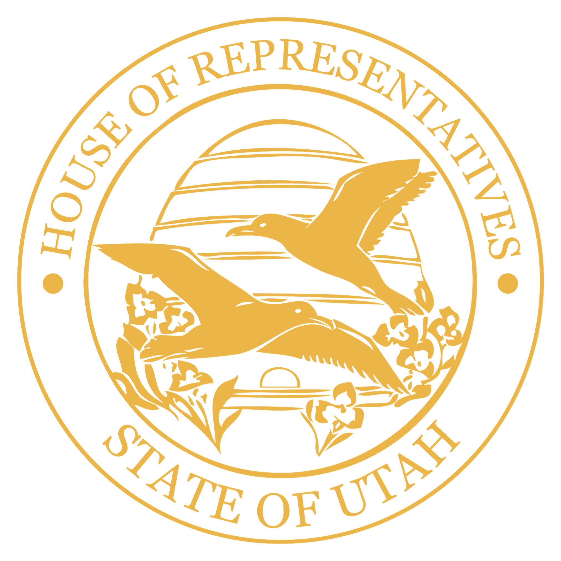

Utah State Legislature
State Capitol | Salt Lake City, Utah

For Immediate Release
November 11, 2025

Contacts
Aundrea Peterson
Utah Senate
801-791-3365 | aundreapeterson@le.utah.gov

Alexa Musselman
Utah House of Representatives
801-865-5882 | amusselman@le.utah.gov

Legislative Leadership Responds to Court Decision

SALT LAKE CITY – President J. Stuart Adams and Speaker Mike Schultz release the following statement:

“Late last night, a single unelected judge set aside the Utah Constitution and the voice of Utah voters, selecting a map drawn behind closed doors by out-of-state advocacy groups. The process the judge chose denied the people of Utah a chance to see it, to weigh in, or to be heard. The judge disregarded the Constitution to select a clearly gerrymandered map. This is not fair to Utahns and is deeply disappointing.

“This isn’t how government should work. Our system depends on transparency, accountability, and respect for the roles defined in our Constitution. Judges are meant to uphold the law as written, not rewrite it to serve political ends. Nothing in Utah’s Constitution gives the courts authority to impose maps designed by private groups.

“Redistricting is not a courtroom exercise; it is a constitutional duty entrusted to the Legislature, the body directly elected and accountable to Utahns. When that process is overridden, it weakens the voice of every Utahn.

Utahns deserve leaders who will defend their voice, their Constitution, and the balance of powers that make our system work. This moment calls for unity and resolve, to stand together, but firmly, in defense of the principles that make Utah strong and the Republic process we all depend on.”

###

