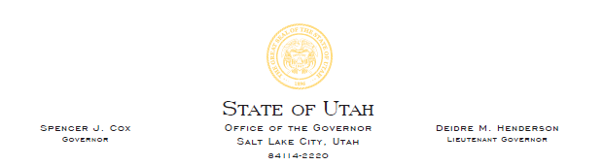
FOR IMMEDIATE RELEASE
Oct. 7, 2021

Gov. Cox, Lt. Governor Henderson, Attorney General Reyes, President Adams and Speaker Wilson express disappointment in Biden administration’s decision
to expand Utah monuments

SALT LAKE CITY (Oct. 7, 2021) – Gov. Spencer J. Cox, Lt. Gov. Deidre Henderson, Attorney General Sean Reyes, President J. Stuart Adams and Speaker Brad Wilson express their frustration and disappointment in the Biden Administration’s decision to expand Utah’s Grand Staircase-Escalante and Bears Ears National Monuments:
“We learned this afternoon from Secretary Haaland that President Biden will soon be announcing the restoration of both Grand Staircase-Escalante and Bears Ears National Monuments.
“President Biden’s decision to expand the monuments is disappointing, though not surprising. For the past 10 months, we have consistently offered to work with the Biden Administration on a permanent, legislative solution, one that would end the perpetual enlarging and shrinking of these monuments and bring certainty to their management. Our goal has been to make lasting progress on managing our public lands for the benefit of all those who use them, particularly those who live on and near those lands.
“We expected and hoped for closer collaboration between our state and national leaders, especially on matters that directly impact Utah and our citizens. The president’s decision to enlarge the monuments again is a tragic missed opportunity—it fails to provide certainty as well as the funding for law enforcement, research, and other protections which the monuments need and which only Congressional action can offer.
“As Chief Justice Roberts noted earlier this year, the purpose of the Antiquities Act is to protect the “smallest area compatible with the care and management” of significant archeological or historical objects to be protected. We agree and will consider all available legal options to that end.
“We are equally disappointed that the Bureau of Land Management’s headquarters will be moving from Colorado to Washington, D.C. – thousands of miles away from over 90 percent of the country’s federally-owned and managed lands. Locating the BLM away from the nation’s capital and near the lands managed brought a valuable new perspective to the BLM and should have served as a model for other federal departments.
“These decisions clearly demonstrate the administration’s unwillingness to collaborate with and listen to those most impacted by their decisions. We remain hopeful that a long-term solution will be reached in the future and that the exhausting policy instability over Utah’s public land can come to an end.”
###

