
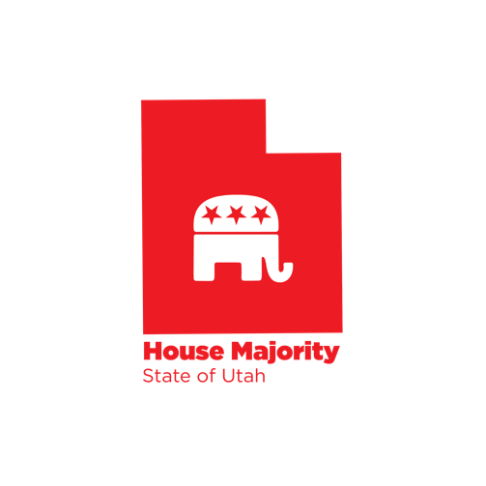
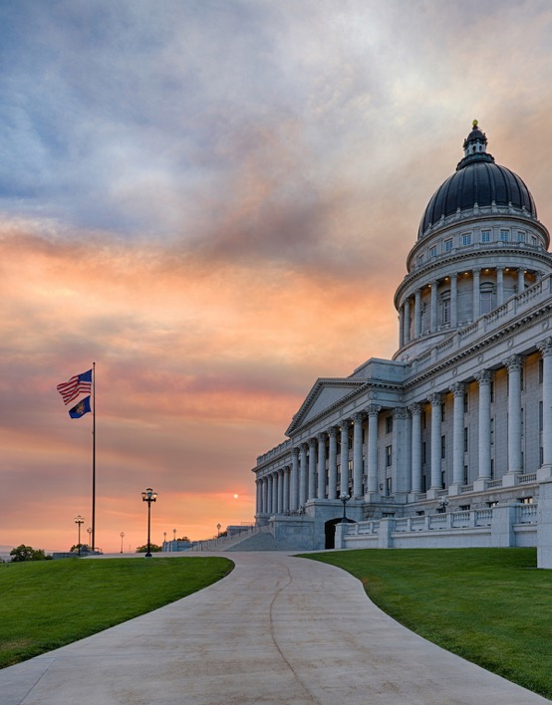





Interim Update

COVID-19 Update
August 28, 2020

Upcoming Events & Census
Unemployment
Page 5
Page 4
LEGISLATIVE
Page 2
Page 3

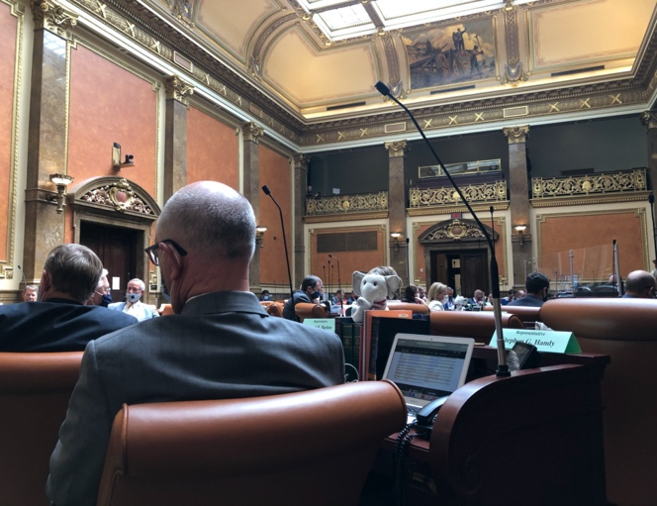

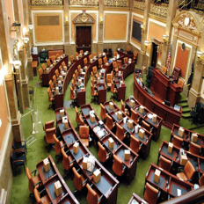

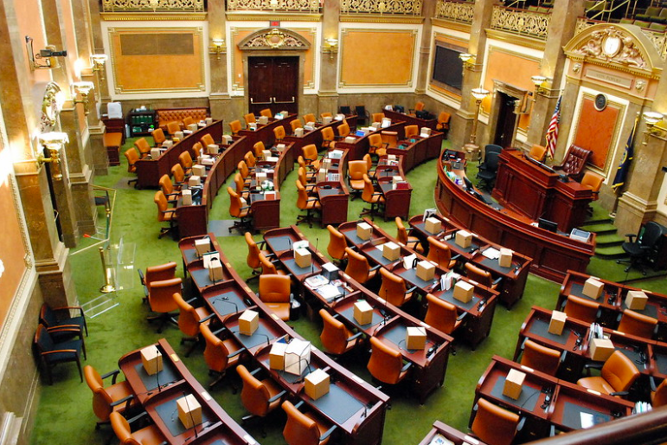

The Legislature held interim meetings last week. Click here to view highlights from interim committees. This link also provides summaries of bills passed during the Sixth Special Session.

The Utah Legislature allocated much of the remaining CARES Act funds. Listen to the attached podcast to learn more.

Interim Updates
Page 2
Utah’s COVID-19 Case Counts from August 24-28

Monday, August 24
- 49,364 positive cases, an increase of 249 from the previous day
- 626,354 total tests administered
- 130 current hospitalizations
- 390 total deaths, 5 more than the previous day
- 41,164 recovered cases

Tuesday, August 25
- 49,767 positive cases, an increase of 403 from the previous day
- 630,599 total tests administered
- 124 current hospitalizations
- 397 total deaths, 7 more than the previous day
- 49,767 recovered cases
Wednesday, August 26
- 50,174 positive cases, an increase of 407 from the previous day
- 637,329 total tests administered
- 118 current hospitalizations
- 401 total deaths, 4 more than the previous day

Thursday, August 27
- 50,557 positive cases, an increase of 383 from the previous day
- 642,761 total tests administered
- 120 current hospitalizations
- 403 total deaths, 2 more than the previous day
- 42,512 recovered cases

Utah’s 7-day rolling average for positive tests is 366 per day. The rolling 7-day average for percent of positive laboratory tests is 8.7%.

For more information please visit https://coronavirus.utah.gov/. You can also call 1-800-456-7707 to receive help.

.

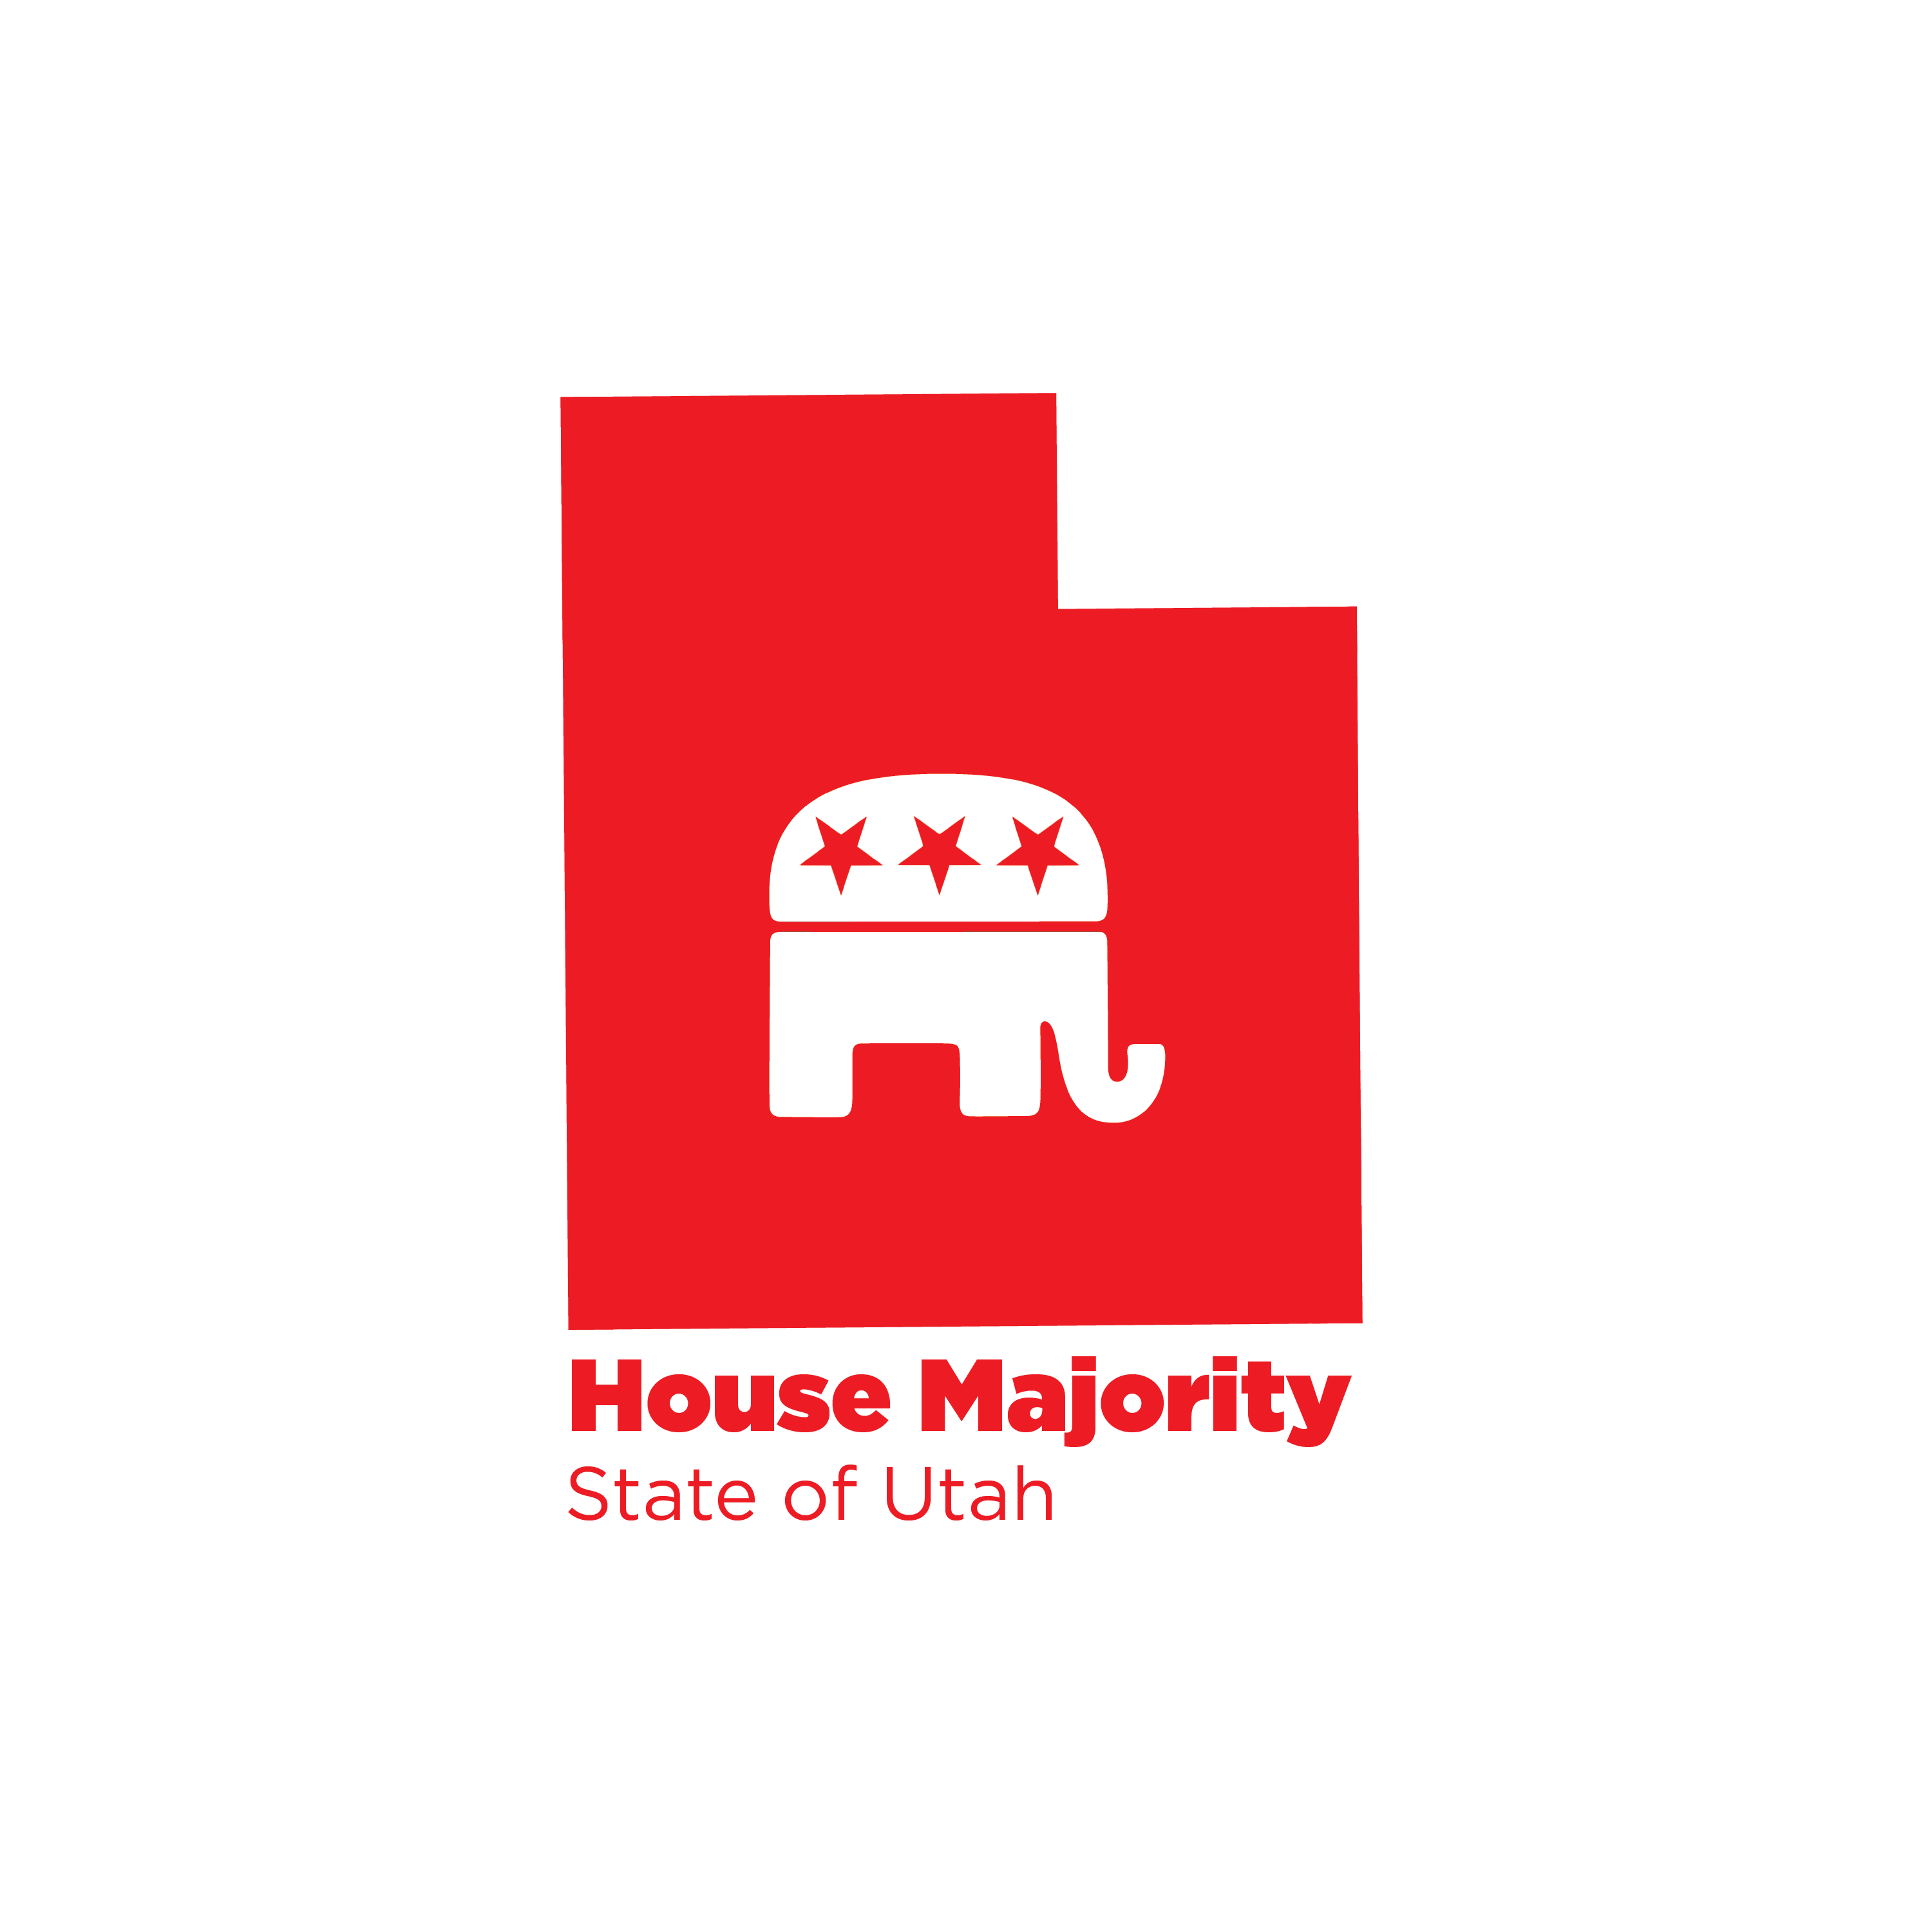

COVID-19 Update
Page 3

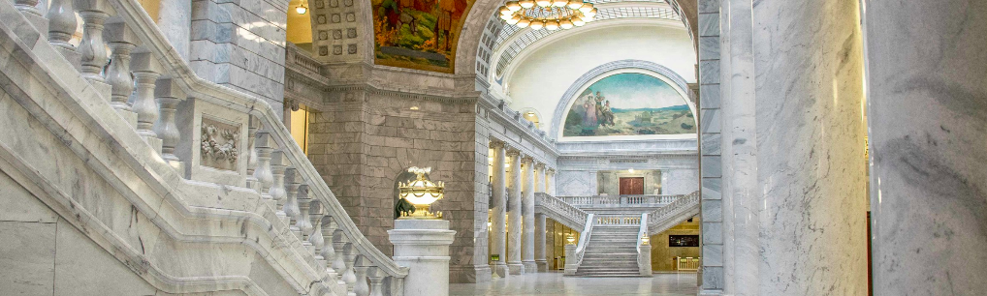


Unemployment Update
Below is the latest information on Utah’s unemployment insurance claims from the Department of Workforce Services. A few key points to highlight from last week (August 16-22):
- Traditional unemployment insurance new claims decreased slightly by 0.2% from the previous week to 2,999 claims
- Pandemic Unemployment Assistance new claims increased by 16.7% from the previous week to 957 claims
- Pandemic Extended Unemployment Claims increased by 11.7% from the previous week to 1,672 claims
- Total new claims for all three programs ended the week at 5,628 (see claim graph below)
- Combined weekly claims for all three programs was at 60,773
- Total combined numbers from March 15 to August 22
  - New claims: 285,438
  - Benefits paid: $1,372,657,416

DWS has been getting questions about the Lost Wages Assistance, which will provide an additional $300 to eligible claimants for only the weeks from July 25-August 15. It is important to point out that there are some key differences between this program and the previous $600 weekly stimulus.
- Utah, and other states, were only approved for the $300 weekly addition for three weeks.
- No one needs to apply for the addition. If a claimant is eligible they will automatically receive the additional benefit within the next three weeks.
- Not every claimant will receive it. The federal guidelines indicate that only those receiving an unemployment weekly payment of $100 or more are eligible for additional benefit. Also, their loss of employment or wages must be caused by the pandemic.

To learn more about Lost Wages Assistance, click here for an FAQ.

Unemployment
Page 4





Septemberer
Page 6



UPCOMING
Census
The amount of federal funding Utah receives for healthcare, education, and transportation is dependent on census participation. Please take the census if you have not yet done so. Click here for more information and to fill out the survey: https://census2020.utah.gov/

15-16
Interim
Committee

