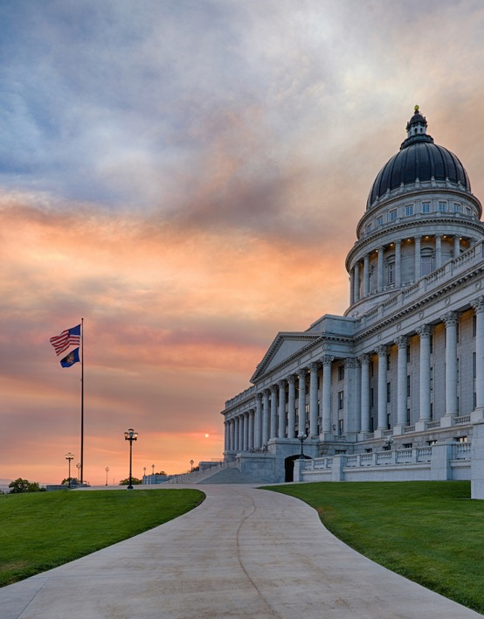
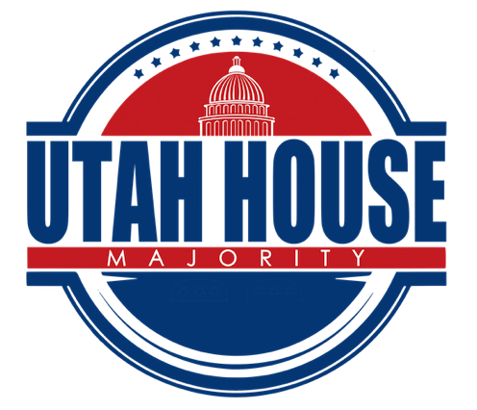

Page 6-9
Page 2-3
Session Overview
Education Funding
PolB
Page 4-5
COVID-19

2020 LEGISLATIVE
Week 7

Page 2

Session Overview
The 2020 General Legislative Session has come to a conclusion. Many great things were accomplished over the span of the last 45 days. On the first day of the session, Speaker Wilson shared a video as part of his opening remarks to highlight some of the key policy areas we would work on during the session. We have accomplished those things plus much more.

Health Care
PBMs
HB 272 Pharmacy Benefits Amendment unanimously passed both the House of Representatives and Senate. This bill will significantly benefit Utahns by increasing drug price transparency and bending the cost curve on health care.

Insulin
Today, HB 207 Insulin Access Amendments unanimously passed the Senate. This bill will make insulin more affordable, and therefore attainable, for all Utahns.

Outdoor Recreation
Outdoor Adventure Commission
We enjoy some of the best outdoor recreation in the world. We want to preserve and increase access to these wonders for future generations to enjoy.
HB 283 created the Outdoor Adventure Commission that would focus on:
- Strategic planning for statewide collaboration
- Stewardship to preserve assets for future generations
- Access for all Utahns

Infrastructure
Electric Vehicle Infrastructure
HB 396 Electric Vehicle Charging Infrastructure Amendments is an air quality bill that creates a public-private partnership with Rocky Mountain Power that invests in statewide electric transportation infrastructure. Studies show that our air is in fact getting cleaner, and we believe these pieces of legislation will continue to move the needle in big ways!

Page 2
Page 2
Page 3
Page 3
Session Overview

Point of the Mountain
We funded the Point of the Mountain’s environmental impact study so further planning and work can take place.

Double tracking front runner
As the state continues to grow, we cannot continue to broaden roads. A comprehensive transit system is an essential aspect of our future. That is why we have funded the double tracking and electrification of the frontrunner to create more frequent and quicker trips.

Education
Higher Education
The legislature passed SB 111 Higher Education Amendments this session, another monumental bill that will transform our systems of higher education in the state of Utah. SB 111 will increase access to and opportunities for postsecondary education for all Utahns, create seamless education pathways for our students, from certificates to degrees, improve coordination and collaboration between institutions, and meet the needs of a growing population and a growing workforce.

Public Education
Each year, lawmakers work to address education funding. This year is no different, as we have searched for solutions to create a stable and reliable funding source for our public education system. After working tirelessly with the education community, the legislature passed HB 357 and SJR 9. These two bills will help us better fund the needs of our state and help us better fund public education. Please read more about the proposal below and read letters and statements of support here:https://house.utah.gov/utah-lawmakers-and-education-stakeholders-make-historic-announcement/.

Page 4

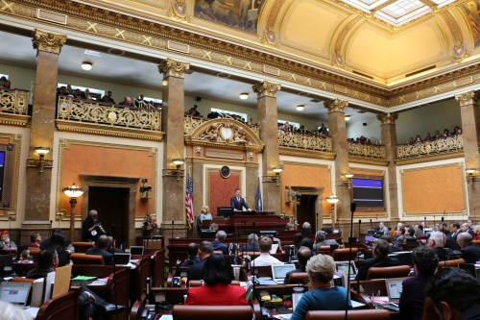
Page 6

Bills Passed by the House: Week 6
Page 6
We are taking COVID-19 very seriously and are trying to do our part to reduce its spread. Thursday morning, legislative leaders released the following statement and took part in a press conference with the Governor, the state epidimologist, and leaders of our state’s education community.
------------------------------------------------------------------------------------------------------------------------
In an effort to protect Utah seniors, Senate President Stuart Adams and Speaker of the House Brad Wilson announced a plan to allocate over $24 million to bolster efforts by health departments and other organizations to prevent the spread of COVID-19 among a group particularly susceptible to the virus.
“Utah has a rainy-day fund, a culture of preparedness and the best health care personnel in the country who specializes in infectious diseases,” said President Adams. “Elderly are at a higher risk and why we are funding programs to protect those most vulnerable. We have conquered similar challenges in the past and will continue to work together to overcome this while minimizing the burden to Utahns and our businesses. Our strong economy gives us the flexibility to handle this situation.
Prior to closing the 2020 general session, legislators will vote to include additional funding for:
- $250,000 to Meals on Wheels, a program targeted to assist senior citizens
- $250,000 to the Food Box Program that provides 10 days worth of boxed meals to seniors
- $250,000 in new home medical testing services to help minimize the spread of the illness
- $250,000 in home supportive services program for vulnerable populations
- $2 million for local health departments to create intensive response programs for seniors
These funds are in addition to the $16 million given to the Division of Finance and the $4 million taken from the Disaster Recovery Restriction Account.
“All Utahns should take reasonable precautions to prevent the spread of the COVID-19 virus,” said Speaker Wilson. “Health experts have warned that people of advanced age are at a higher risk of developing significant health issues as a result of contracting the virus. As county health workers and other organizations that care for the elderly are already doing great work, we want to ensure they have the funds they need to help seniors and others affected by the virus.”
Throughout the session, lawmakers considered potential options to give Utahns a tax refund or tax cut. Growing concern about COVID-19 and its potential impact on the economy led legislators to hold off on such a move, choosing instead to appropriate money for seniors and save the $80 million under consideration for the time being.
Legislators are wearing white ribbons on the final day of the session to express appreciation for health care workers who are working on a vaccine, testing for the virus and caring for those infected.
Legislative leaders reiterate their support for the work done by the Utah Coronavirus Task Force and emphasize the importance for all Utahns to adhere to recommendations made by health experts, including frequent handwashing, avoiding unnecessary close contact, covering coughs and sneezes and staying home if you are sick.
COVID-19 Update

Page 6
Bill Title
Description of Bill
Bill Title
Description of Bill
Description of Bill
Bill Title
My Legislation
Education Press Conference

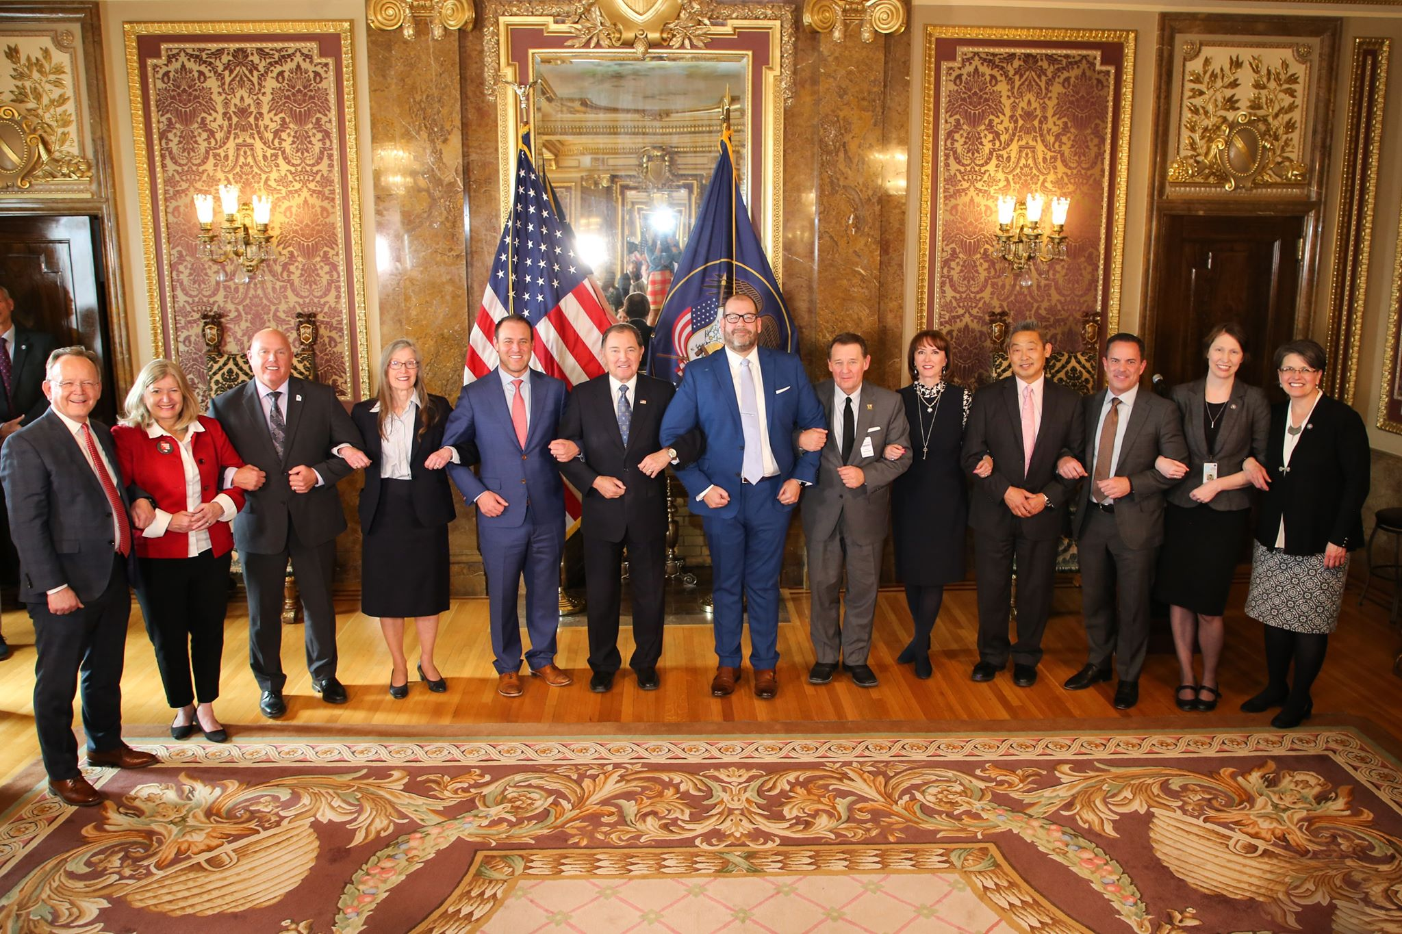


fForf
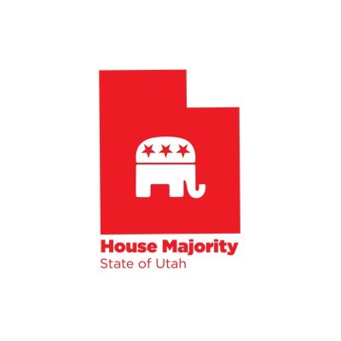
For more pictures, check out our Flikr:


Follow us on social media!


\

@utahreps

