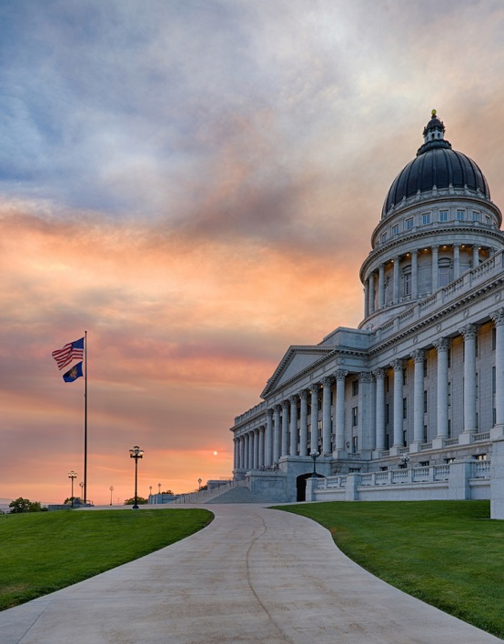
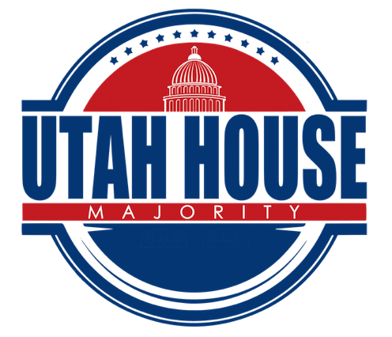

Page 4-6
My Legislation
Page 7
Bills Passed
Page 3
Education Funding
PolB
Page 2
Week 6 Overview
2020 LEGISLATIVE
Week 6

Page 2

Week 6 Overview
Gubernatorial Candidates & Congressional Delegation Visits to Caucus
Throughout the session, our caucus will be visited by the Republican gubernatorial candidates. We are also visited by members of our congressional delegation. Last Friday we were visited by Senator Mitt Romney and Spencer Cox. This week, we were visited by Greg Hughes.

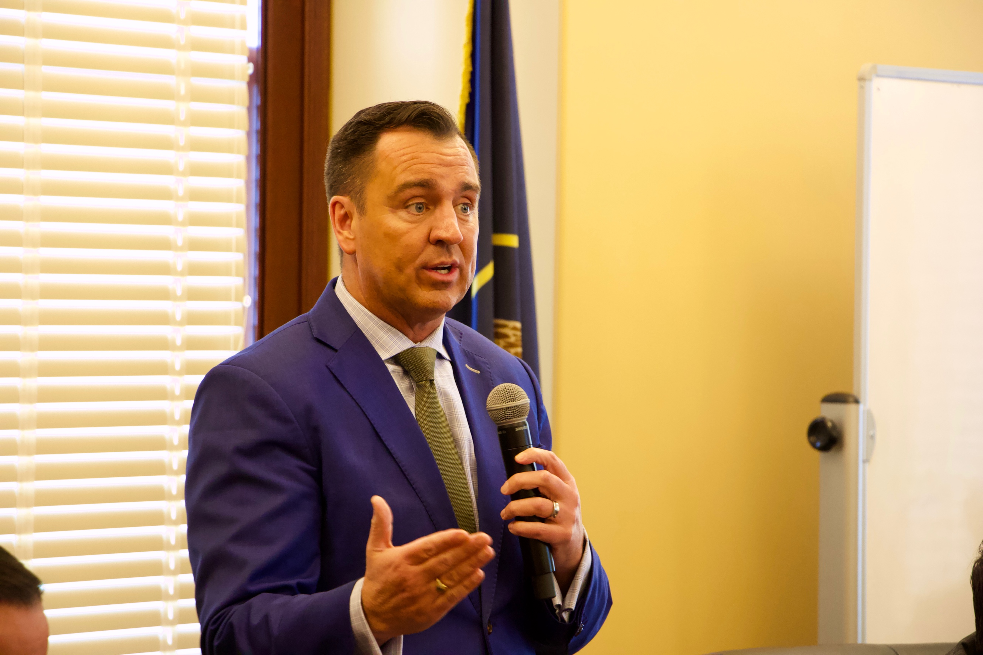
Coronavirus
On Monday, Governor Herbert announced the creation of the coronavirus task force - made up of health care providers and state and community stakeholders - and the state’s plan to mitigate COVID-19 and minimize disruption in Utah. We are confident in the task force’s efforts and encourage everyone throughout the state to take the advised precautions outlined by the CDC and task force. To find current and accurate information on COVID-19 in Utah, follow @CoronavirusUtah on twitter and visit Coronavirus.utah.gov

Pharmacy Benefits Amendment
Utahns spend more out-of-pocket for their health care and prescription drugs than the average American. Branded drug prices have nearly tripled since 2008 and for every dollar spent on health care, only 23.3 cents goes towards prescription drugs. Representative Ray’s bill, HB 272 Pharmacy Benefits Amendment will address these concerns and significantly benefit Utahns by increasing drug price transparency and bending the cost curve on health care. HB 272 unanimously passed the House of Representatives and has moved to the Senate.

Page 2
Page 2
Page 3
Page 3

Education Funding
The legislature heard SJR 9 and HB 357 this week, two bills which are of significant importance. We have been working closely with education leaders and stakeholders to craft a proposal that will help address our state budget’s structural imbalance and reduce volatility in education funding. The proposed solution modifies the constitution to allow income tax revenue to serve children and individuals with disabilities while still protecting, stabilizing, and growing public education funding. Additionally, this proposal includes no tax increases. This proposal will only go into effect if Utah voters approve the amendment during the 2020 general election.

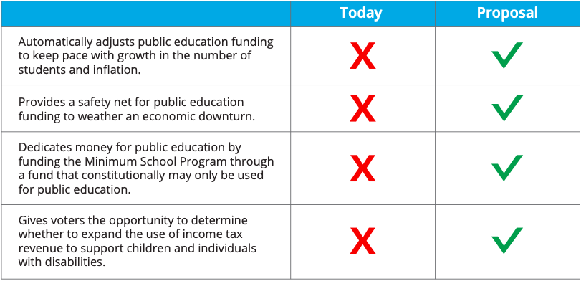

Education Funding

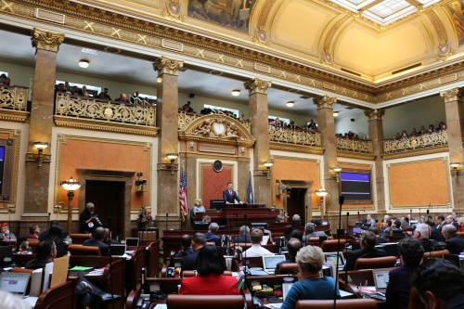
Page 4

Bills Passed by the House: Week 6
HCR 14 Concurrent Resolution Reaffirming Utah’s Important Relationship with Taiwan
HC13 Concurrent Resolution Supporting the Protection and Restoration of Wildlife Corridors
HB 335 Illegal Activities on Trust Lands Amendments
HCR 19 Concurrent Resolution Opposing the Introduction of Wolves
HCR 16 Concurrent Resolution Calling for the Creation of a National Federalism Task Force
HJR 15, 1st Sub Proposal to Amend Utah Constitution – The Right to Hunt and Fish
HB 359 Municipal Annexation Revisions
HCR 18 Concurrent Resolution Commemorating the 400th Anniversary of the Historic Voyage of the Mayflower and the Signing of the Mayflower Compact
HB 59 Tax Credit for Alternative Fuel Heavy Duty Vehicles
HB 157, 1st Sub Wine Services and Amendments
HB 313, 1st Sub Telehealth Parity Amendments
HB 235 2nd Sub Voluntary Home Energy Information Pilot Program
HB 108 Medical Specialists in Public Schools
HB 300, 1st Sub Justice Court Jurisdiction Amendments
HB 23, 2nd Sub Tobacco and Electronic Cigarette Amendments
HB 166 Watershed Councils
HB 10, 2nd Sub Boards and Commissions Amendments
HB 344, 1st Sub Sex Offender Restrictions Amendments
HB 271 1st Sub Firearm Preemption Amendments
HB 269 2nd Sub Tax Credit Amendments
HB 356 1st Sub Railroad Amendments
HB 275 Elected Official and Judicial Compensation Commission Amendments
HB 348 Business Licensing Amendments
HB 304 Citizen Feedback Program
HB 363 Public Employees’ Health Plan Amendments
HB 350, 1st Sub Impaired Driving Amendments
HB 206, 3rd Sub Bail and Pretrial Release Amendments
HB 308 Lien Amendments
HCR 21 Concurrent Resolution Celebrating the 50th Anniversary of Earth Day
HB 146, 3rd Sub Driver License Suspension Amendments
HB 372, 1st Sub Digital Wellness, Citizenship, and Safe Technology Amendments
HB 366 Utah Alternative Dispute Process for ADA Complaints Act
HB 211, 2nd Sub Renter Expenses Disclosure Requirements
HB 227, 1st Sub Motor Vehicle Insurance Revisions
HB 392, 1st Sub Early Warning Program Amendments
HB 340, 1st Sub Rampage Violence Prevention Study
HB 362 Overdose Reporting Amendments
HB 226, 2nd Sub Storm Water Permitting Amendments
HB 389, 2nd Sub Emergency Medical Service Amendments
HB 331 Water Infrastructure Safety and Maintenance

Page 5
HB 311 Controlled Substance Enhancement Amendments
HB 370 Tourism Information Amendments
HB 242 Charter School Operations Amendments
HB 282 Voluntary Firearms Restrictions Amendments
HB 358 Poultry Amendments
HB 371 Wildlife Tagging Amendments
HB 423 Controlled Substances Database Act Amendments
HB 407 Regulatory Sandbox Amendments
HCR 20 Concurrent Resolution Honoring the Utah Hospital Association for 100 Years of Service
HB 289 Public Education Retirement Amendments
HCR 22 Concurrent Resolution Concerning the Protection, Development, and Beneficial Use of Utah’s Colorado River Compact Allocation
HB 373 Attorney General Fund Amendments
HB 374, 1st Sub Local Government Building Regulation
HB 382 Property Tax Records Amendments
HB 400, 1st Sub National Guard Training Amendments
HB 388, 1st Sub Land Use Development and Management Revisions
HB 62, 2nd Sub Enterprise Zone Tax Credit Amendments
HB 347, 1st Sub Inland Port Modifications
HB 232, 2nd Sub Food Revisions
HB 158, 2nd Sub Data Privacy Amendments
HB 349 Insurance Modifications
HB 360 Interactive Reading Software Amendments
HB 376 Dropout Prevention Amendments
HB 328, 2nd Sub Division of Water Resources Study Update
SB 75, 1st Sub Legislative Audit Amendments
SB 51, 2nd Sub Secondary Water Requirements
SB 142 Delivery Driver Age Requirements
SB 109, 1st Sub New State Construction Set-aside for Art Amendments
SB 67, 3rd Sub Disposition of Fetal Remains
SB 34 Sex Offender Registry Amendments
SB 113, 1st Sub Arts Program Funding Amendments
SB 143 Fiscal Impact of Initiatives
SB 23, 2nd Sub Division of Occupational and Professional Licensing Amendments
SCR 6, 1st Sub Concurrent Resolution for Study of Local Option Sales Tax
SB 149, 1st Sub Occupational and Professional Licensing Amendments
SB 111, 1st Sub Higher Education Amendments
SB 127 Nursing Licensing Amendments
SB 110 Electronic Driver License Amendments
SB 130, 1st Sub 911 Communications Amendments
SB 154, 1st Sub Taxed Interlocal Entity Amendments
SB 100 State Institutional Trust Lands Administration Amendments

Bills Passed by the House: Week 6
Page 6

SB 144 Water Related Process Amendments
SB 67, 4th Sub Disposition of Fetal Remains
SB 148 Oil and Gas Modifications
HB 412 Credit Reporting Notification Amendments
HB 305, 2nd Sub Urban Development Amendments
HB 377 Health Care Funding Amendments
HB 391 School Textbook Fee Amendments
HB 288, 1st Sub Prosecutor Data Collection Amendments
SB 147, 1st Sub School Internship Safety Agreements
SB 125 Single Sign-on Portal Amendments
HB 393 Municipal Annexation Amendments
HB 396, 2nd Sub Electric Vehicle Charging Infrastructure Amendments
HB 332, 3rd Sub Special Needs Scholarship Amendments
SB 62 Reauthorization of Administrative Rules
HB 402, 1st Sub Regulatory Waiver Process
HB 316 Restricted Status Amendments
HB 343 Probate Notice Amendments
SB 131, 1st Sub Mining Amendments
HB 364, 4th Sub Abortion Revisions
HB 272, 2nd Sub Pharmacy Benefit Amendments

Bills Passed by the House: Week 6

Page 7
Bill Title
Description of Bill
Bill Title
Description of Bill
Description of Bill
Bill Title
My Legislation

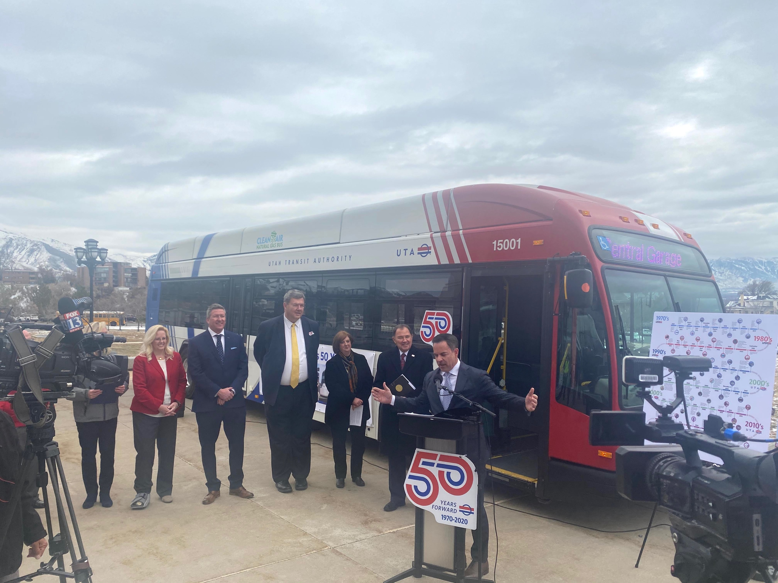
UTA Celebrates 50 Years
Coronavirus Press Conference
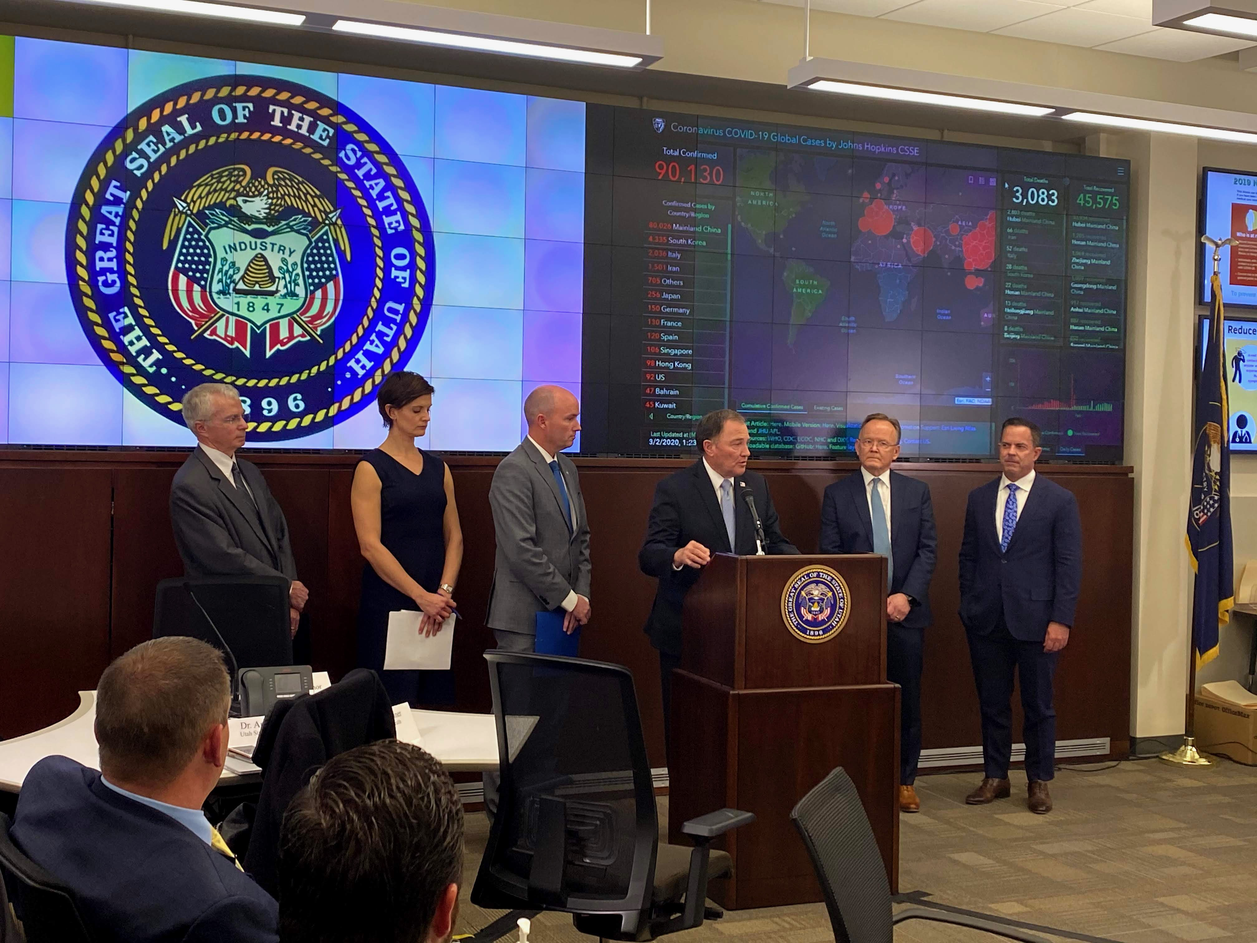
Page 7


fForf
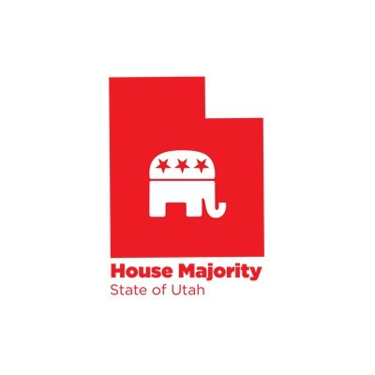
For more pictures, check out our Flikr:


Follow us on social media!


\

@utahreps

