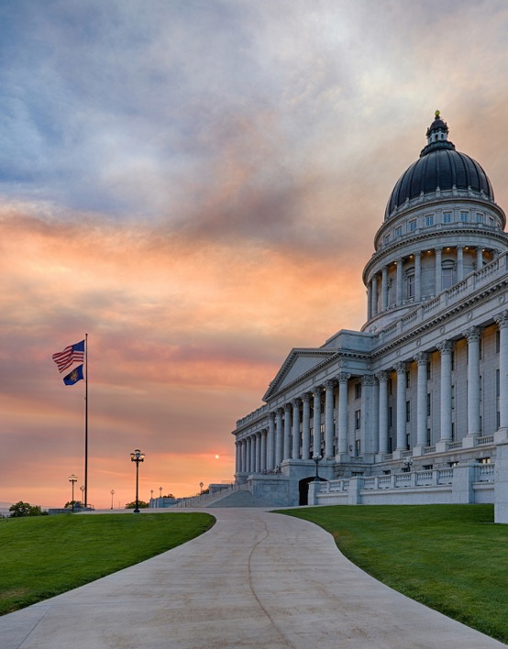
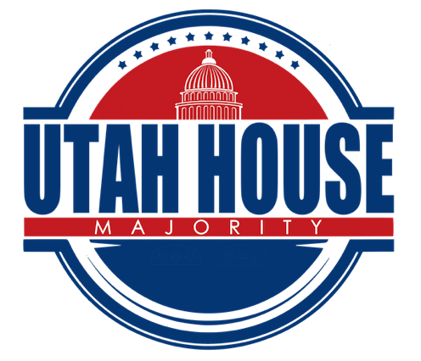

Events
Page 7
My Legislation
Page 6
Page 3-5
Bills Passed
PolB
Page 2
Week 5 Overview
2020 LEGISLATIVE
Week 5

Page 2

Week 5 Overview

Gubernatorial Candidates Visit Caucus
Throughout the remainder of the session, our caucus will be visited by the Republican gubernatorial candidates. This week, we were visited by Jeff Burningham and Jon Huntsman.

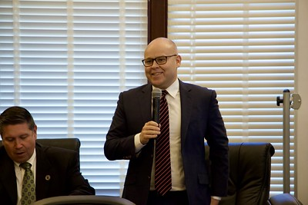

Redistricting
After months of negotiations, the Utah Legislature and Better Boundaries reached an agreement on redistricting. Better Boundaries and legislators from both political parties support this agreement which will allow an independent commission to draw political boundaries based on 2020 census data. This compromise resolves legal complications while still reflecting the voice of the people.

Electric Vehicle Charging Infrastructure Amendments
Last year, the legislature commissioned a study known as the Utah Roadmap to help identify areas of opportunity to further reduce emissions and ensure a healthy, productive, and prosperous future for all Utahns. One of the main areas of opportunity is to position Utah as the market-based electric vehicle state. HB 396 will begin a public-private partnership to help us build a statewide electric transportation infrastructure system. This will allow us to take advantage of new technology and new opportunities.

Budget
Utah currently has one of the lowest unemployment rates in the nation at 2.3% and we enjoy a growing and robust economy. However, we cannot always count on this environment. As a Majority Caucus, we have discussed setting aside a cushion to support us in the case of an economic downturn. We are hopeful that with this, we will be able to continue to support general government, social services, and education even during the hardest of times.

Each year, the Legislature must also balance our state’s budget. We have been ranked as the best managed state in the nation because of these forward-thinking and fiscally responsible decisions.

Page 2
Page 2
Page 3

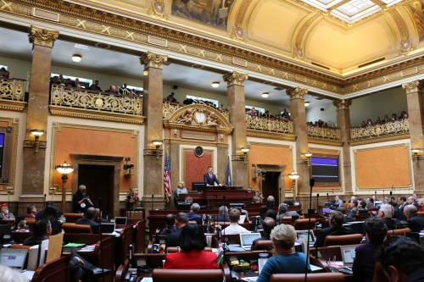
Page 3

Bills Passed by the House: Week 5
HB 283, 1st Sub Outdoor Adventure Commission Amendments
HB 270 Interstate Compact for Economic Development
HB 312, 2nd Sub Maintenance Funding Practices Act
SB 58 Uniform Athlete Agents Act Amendments
SJR 1 Joint Resolution Supporting Coordination of Care for Older Adults Receiving Home Health Care Services
SB 90, 1st Sub Procurement Code Amendments
HR 3 House Resolution Urging the Activation of Closed Captioning in Public Venues
HB 330 Peace Officer Pay Plan Amendments
SB 66 Court Resources Reallocation Amendments
SB 70, 1st Sub Determination of Death Amendments
SJR 6, 2nd Sub Joint Rules Resolution – Conflict of Interest Disclosure
SB 17 Heber Valley Historic Railroad Authority Sunset Date Extension
SB 59 Daylight Saving Time Amendments
SB 65, 1st Sub Child Welfare Amendments
SB 13 Native American Legislative Liaison Committee Amendments
SB 64, 1st Sub Special District Communications Amendments
SB 56, 1st Sub Public Safety and Firefighter Tier II Retirement Enhancements
SB 32, 1st Sub Prisoner Offense Amendments
SB 36 Nonresident Income Amendments
SJR 11 Joint Rules Resolution – Workload Reporting
SB 80, 1st Sub Campus Safety Amendments
SB 88 Environmental Quality Revisions
SB 102, 1st Sub Bigamy Amendments
SB 97 Personal License Plate Amendments
SB 28, 3rd Sub Election Law Revisions
HB 37, 1st Sub Insurance Amendments
SB 45, 1st Sub Uniform Fiduciary Income and Principal Act Amendments
HB 322, 1st Sub Utahraptor State Park
SB 68, 3rd Sub Mental Health Counselor Licensing Amendments
HCR 9 Concurrent Resolution Authorizing State Pick up of Public Safety and Firefighter Employee Retirement Contributions
HB 278, 1st Sub Jordan River Amendments
HB 333, 1st Sub Limited Purpose Local Government Entity Amendments
HB 207, 2nd Sub Insulin Access Amendments
HB 309 World War II Memorial Commission
HB 339 Clean Air Special Group License Plate
HB 120 Towing Fee Amendments
HB 297, 1st Sub Yurt Amendments
HB 240, 1st Sub Driver License Revisions

Page 4
HB 277, 1st Sub Personal Delivery Devices Amendments
HB 334 Civics Education Amendments
HB 336, 1st Sub Concurrent Enrollment Certificate Pilot Program
HB 341 Associate Physician License Amendments
HCR 17 Concurrent Resolution to Create Awareness Regarding the Value of Birth Tissues
HB 346 Recreational Activity Risks Amendments
HB 40, 1st Sub Water Loss Accounting
HB 295, 2nd Sub Fatality Review Amendments
HB 314 Controlled Substance Database Access Amendments
SB 21, 1st Sub Education Amendments
SB 89, 2nd Sub Mental Health Services Amendments
SB 94 Reporting Requirements Amendments
SJR 2 Joint Resolution Encouraging Action to Reduce the Number of Utah Children with Elevated Blood Lead Levels
HCR 10 Concurrent Resolution Honoring the Career and Service of Pastor France A. Davis
HB 12, 2nd Sub Abusive Conduct Reporting Amendments
HB 299, 2nd Sub Opportunity Zone Enhancements
HB 132 Higher Education Student Speech Rights
HJR 18 Joint Resolution Regarding the Winter Sports Park
HB 264, 3rd Sub Infant at Work Pilot Program
HB 171, 2nd Sub School Threat Amendments
SB 79 Regional Education Service Agencies
SB 121, 2nd Sub Medical Cannabis Amendments
HB 294 Mining Operations Amendments
HB 247 Unlawful Sexual Activity Statute of Limitations Amendments
HB 154, 2nd Sub Amusement Ride Safety
HB 186, 2nd Sub Lobbyist Amendments
HB 286 Public Information Website Revisions
HJR 11 Joint Rules Resolution – Technical Amendments
HR 1 House Resolution Remembering the Genocide Against the Tutsi in Rwanda
HB 274, 3rd Sub Delegation of Health Care Services Amendments
HR 2, 1st Sub House Rules Resolution – Amendments to House Rules
HB 262, 2nd Sub Juvenile Delinquency Amendments
HJR 16 Joint Rules Resolution – Amendments to Joint Rules
HB 267, 2nd Sub Prohibited Persons Amendments
HB 298 Victim Guidelines for Prosecutors
HB 168, 1st Sub Public Water Supplier Relocation Amendments
HB 248, 1st Sub Agriculture Revisions
HB 296 Limitations on Landowner Liability Amendments
HB 118, 1st Sub Retail Tobacco Amendments
HB 236, 1st Sub Safe School Route Evaluations
HB 246, 1st Sub Mental Health Workforce Amendments

Bills Passed by the House: Week 5
Page 5

HB 107, 2nd Sub Effective Teachers in High Poverty Schools Incentive Program Amendments
HB 245 Dogs in Watershed Areas
HB 155, 3rd Sub Homeowner Association Provisions Amendments
HJR 14 Joint Resolution Regarding Study and Recommendations for Telegovernment
HB 259 Electric Vehicle Charging Network
HCR 15 Concurrent Resolution Urging a State Funeral for the Last WWII Medal of Honor Recipient
HB 293 Longevity Amendments
HB 276 Administrative Garnishment Order Amendments
HB 266 Water Conservancy District Amendments
HB 315 Local School Board Vacancies Amendments
HCR 12 Concurrent Resolution on Holocaust Education
HB 258 Intergenerational Poverty Interventions Grant Program Amendments
HB 279, 1st Sub Disability Benefit Amendments
HB 312 Heritage and Arts Foundation Amendments
HB 98, 1st Sub Offenses Against the Administration of Governments Amendments
HB 306 Planning Commission Amendments
HB 256 Student Aid Amendments
HB 280, 2nd Sub Transient Room Tax Provisions
HB 290, 1st Sub Occupational Licensing Amendments
HB 77 Education Funding Amendments
HB 101 Distracted Driver Amendments
HB 255, 2nd Sub Boat Fees Amendments
HB 319 Consumer Lending Amendments

Bills Passed by the House: Week 5

Page 6
Bill Title
Description of Bill
Bill Title
Description of Bill
Description of Bill
Bill Title
My Legislation

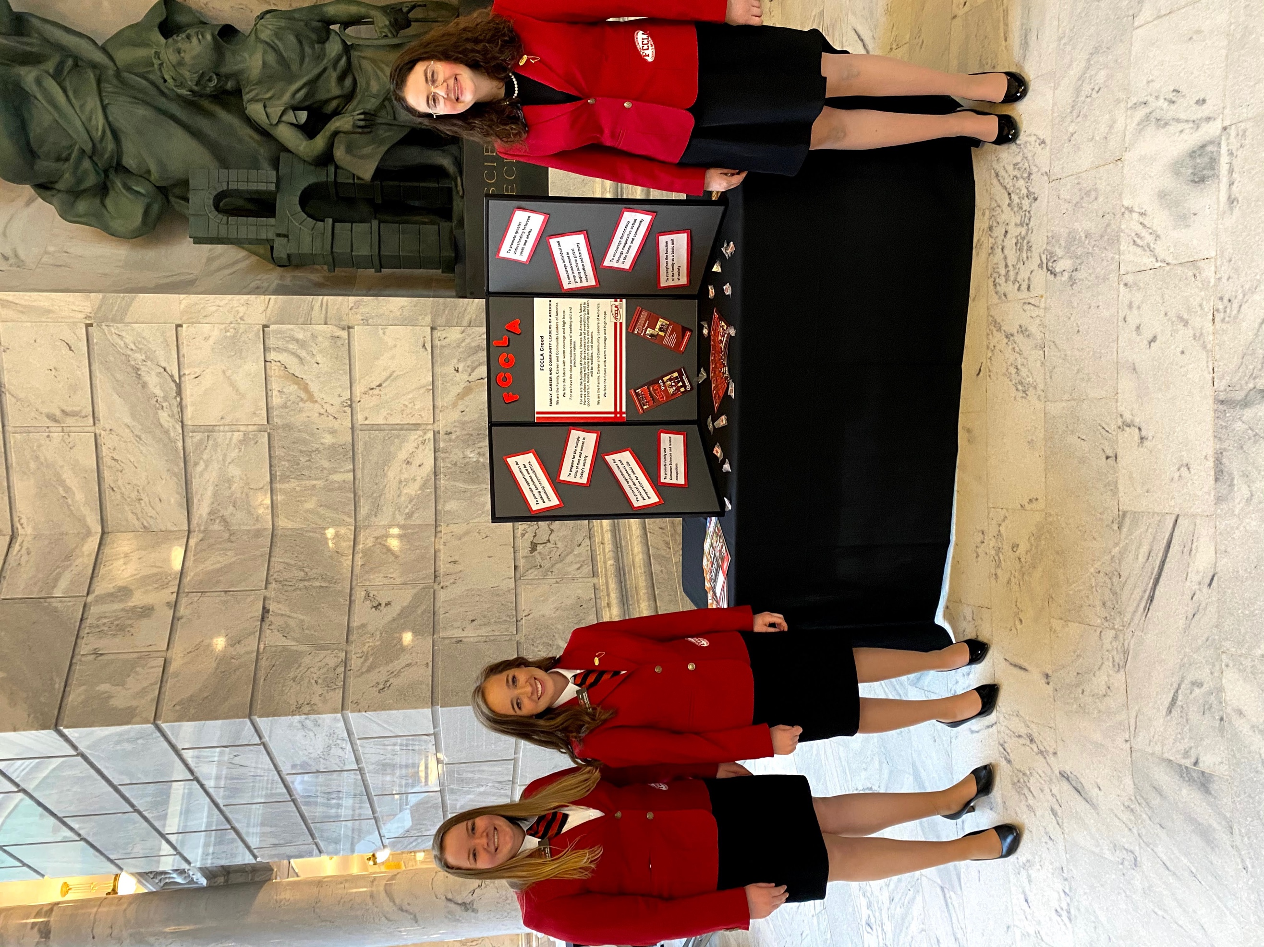
ACTE Day on the Hill
Redistricting Press Conference
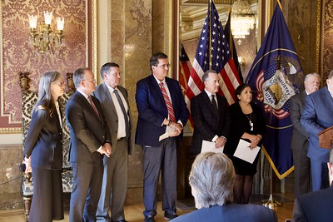
Page 7


fForf
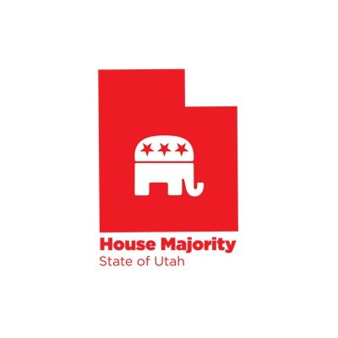
For more pictures, check out our Flikr:


Follow us on social media!


\

@utahreps

