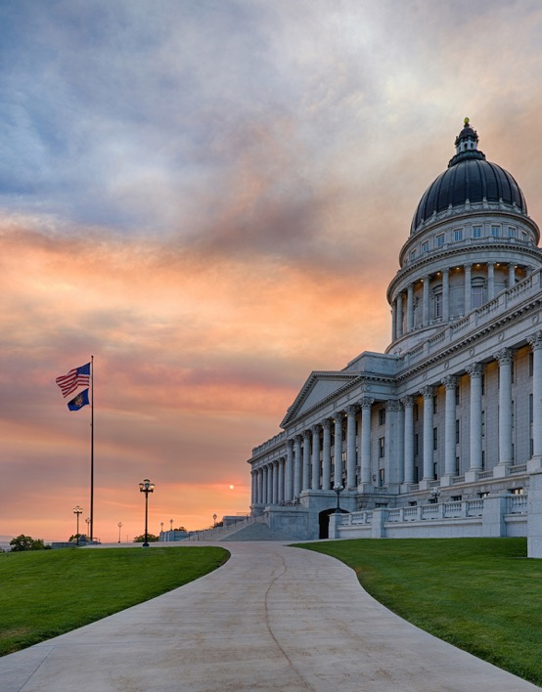
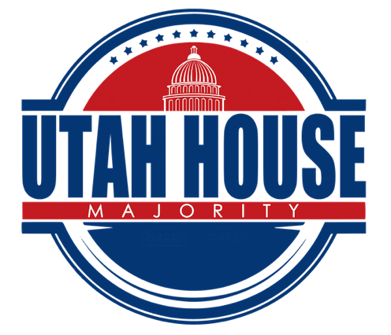

Page 6
My Legislation
Page 7
Events
Bills Passed
Page 4-5
Outdoor Recreation
Pol
Page 3
Week 4 Overview
Page 2
2020 LEGISLATIVE
Week 4


Week 4 Overview
Congressional Delegation Visits Caucus
Throughout the session we are visited by members of our federal delegation. On Tuesday, Senator Mike Lee spoke to our caucus. On Thursday, we were visited by Congressman Ben McAdams and Congressman John Curtis.
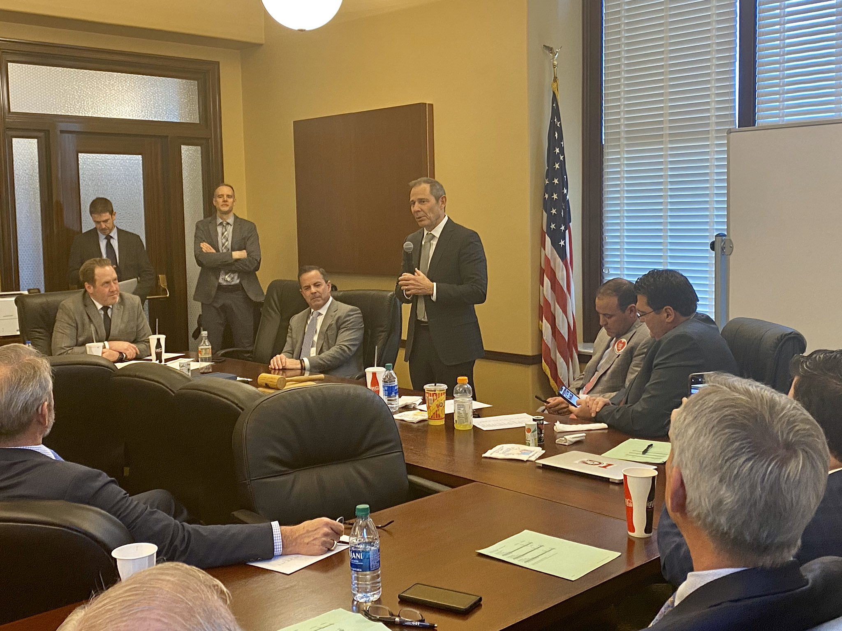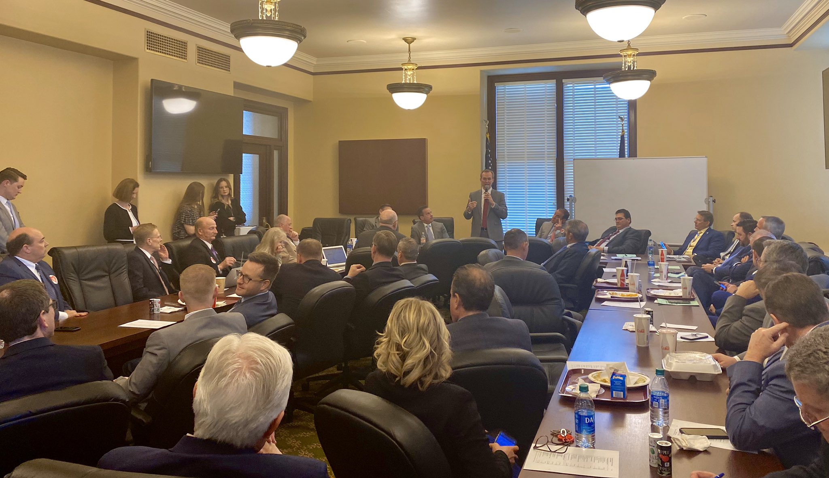

Aimee Winder Newton Visits Caucus
Throughout the remainder of the session, our caucus will be visited by the Republican gubernatorial candidates. On Tuesday, we were visited by Aimee Winder Newton.

Honoring Hondo
Last week, K9 Hondo with Herriman City Police was killed in the line of duty. The House was pleased to honor him and his handler, Sgt. Ricks, with over 33 officers and their K9 partners.

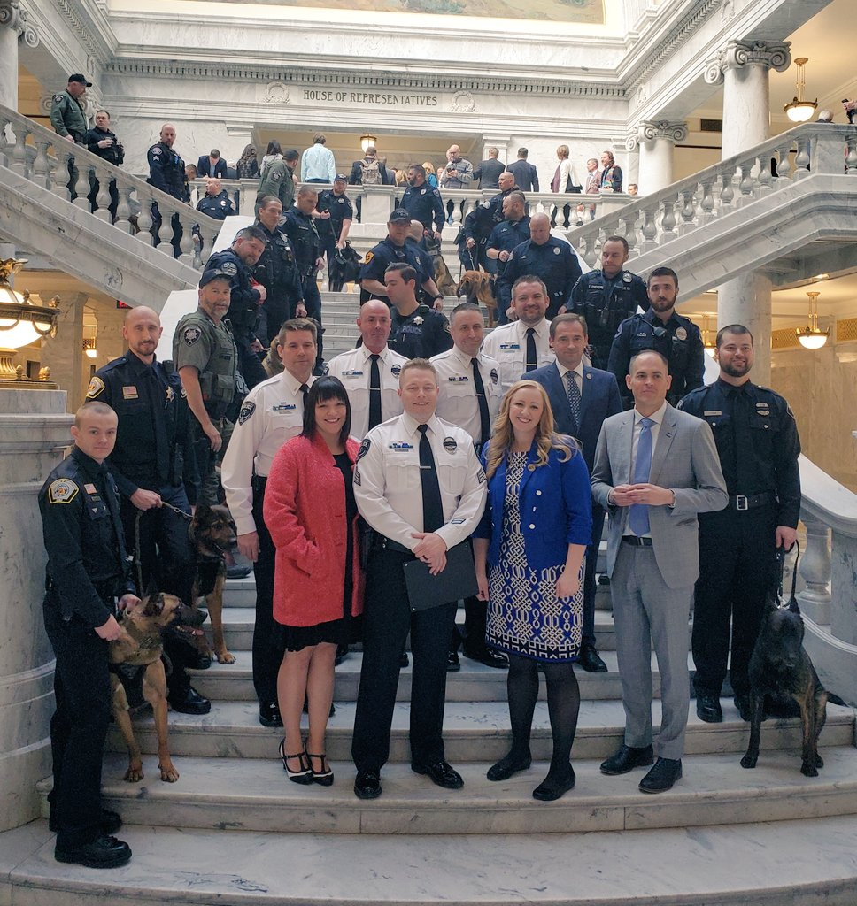

Page 2
Page 2

Week 4 Overview (cont.)

Insulin Pricing
The House Health and Human Services Committee unanimously passed HB 207 this week, helping bend the cost curve on insulin pricing for all Utahns. In 2002, a vial of insulin that cost $20 now costs approximately $350. These skyrocketing prices have made it difficult for individuals to pay for the care they need. HB 207 will be heard on the House floor in coming weeks.

Electronic Cigarettes in Schools
This week the House passed HB 58 Electronic Cigarettes in Schools Amendments (70-0-5) which addresses student use of alcohol, tobacco, and electronic cigarette products through education, prevention, and discipline programs. Today, over 12% of Utah’s youth actively vape. The Legislature is working to combat this crisis and keep our kids safe and healthy.

Outdoor Recreation
It is no secret that Utah is home to incredibly diverse natural landscapes that give us some of the best outdoor recreation in the world. It's part of what makes living in Utah exceptional. We want to maintain the outdoors we love for future generations to enjoy.

However, as our state continues to grow, some of our recreation assets are not keeping pace. We need a statewide, comprehensive outdoor recreation plan to preserve and protect the outdoors, while creating sufficient access for all Utahns.

HB 283 creates the Outdoor Adventure Commission which will help us preserve and grow this essential benefit for future generations to enjoy. The Outdoor Adventure Commission’s goal is to:
- Create strategic planning for state-wide collaboration with all organizations and entities.
- Increase access to outdoor recreation opportunities for all Utahns.
- Focus on stewardship to preserve these assets for future generations.

The Outdoor Adventure Commission will be made up of various stakeholders representing the many aspects of our state, outdoor recreation, conservation, industry and so on. Together they will work towards addressing these goals.

Watch this video to learn more: https://www.youtube.com/watch?v=6VKLrSWb-h8&t=4s

Page 2
Page 3

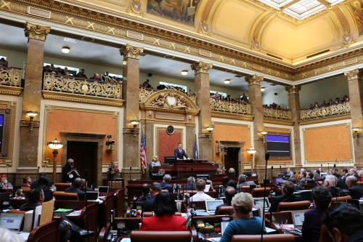
Page 4

Bills Passed by the House: Week 4
HB 83, 1st Sub Expungement Amendments
HB 142, 1st Sub Criminal Proceeding Amendments
HB 159, 2nd Sub Insurance Coverage Revisions
HB 169 Exemptions Amendments
HB 179 Recycling Market Development Zone Tax Credit Amendments
HB 200 Addition to Income Revisions
HB 134 Raw Milk Products Amendments
HB 228 Livestock Predators Removal Amendments
HB 67, 1st Sub Local Education Agency Financial Information Systems
HB 68, 1st Sub Apprenticeship and Work-based Learning Amendments
HB 205 Students with Disabilities Amendments
HB 222, 1st Sub Start Smart Utah Breakfast Program
HB 214, 1st Sub Insurance Coverage Modifications
HB 162 Securities Amendments
HB 244, 1st Sub Fetal Exposure Reporting and Treatment Amendments
HB 243, 1st Sub Warning Labels Amendments
HB 105 Water Facilities Amendments
HB 197, 1st Sub Fishing and Hunting Restrictions for Nonpayment of Child Support
HB 116, 2nd Sub Murdered and Missing Indigenous Women, Girls, and LGBTQ+ Task Force
HB 213, 1st Sub Consent Language Amendments
HB 127 Motorcycle Right-of-way Amendments
HB 183, 2nd Sub Driver License Record Amendments
SB 72 Revisor’s Technical Corrections to Utah Code
HB 60 Corporate Income Tax Credit Amendments
HB 33, 1st Sub Abuse, Neglect, and Dependency Proceedings Amendments
HB 64, 2nd Sub Custody and Visitation Rights Amendments
HB 292 Internet Voting Study
SB 72 Revisor’s Technical Corrections to Utah Code
SJR 7, 2nd Sub Joint Resolution Authorizing Pay of In-session Employees
SB 54 Mobile Home Amendments
HB 161, 1st Sub Audiology and Speech-language Pathology Interstate Compact
HB 208 Alcohol Education Amendments
HB 174 Rural County Health Care Facilities Tax Amendments
HB 96 Water Forfeiture Amendments
SB 47 Public Document Signature Classification
SB 48 Corrections Officer Certification Pilot Extension

Page 5

Bills Passed by the House: Week 4
HB 202 Local Government Nuisance Ordinance Reform
HB 66, 3rd Sub Wildland Fire Planning and Cost Recovery Amendments
SCR 3 Concurrent Resolution Honoring Watura Misaka
HB 212 Vehicle Sales Tax Exemption Modifications
SB 50 Clean Energy Act Amendments
HB 192, 1st Sub Property Tax Assessment Amendments
HB 268 Property Tax Notice Amendments
HB 198 Eminent Domain Limitations
HB 225 Phased Retirement Amendments
HB 58, 1st Sub Electronic Cigarettes in Schools Amendments
HB 32, 2nd Sub Crisis Services Amendments
HB 219 Mental Health Amendments
HB 285 Utah Professionals Health Program
HB 139, 1st Sub DUI Liability Amendments
HB 220 Hepatitis C Outreach Pilot Program
HB 238, 1st Sub Crime Enhancement Amendments
HB 291, 1st Sub Human Trafficking Amendments
HB 92, 1st Sub Fire Amendments
HB 130 Water Use Amendments
HB 233, 2nd Sub Natural Resources Legacy Funding Amendments

Page 6
Bill Title
Description of Bill
Bill Title
Description of Bill
Description of Bill
Bill Title
Page 7
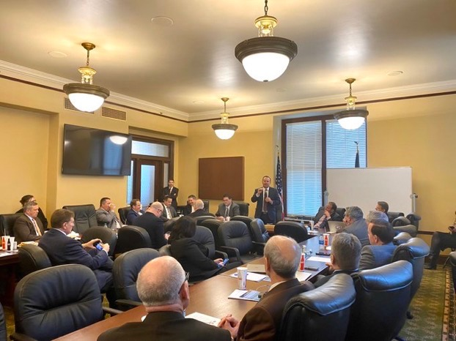
Robotics Day on the Hill

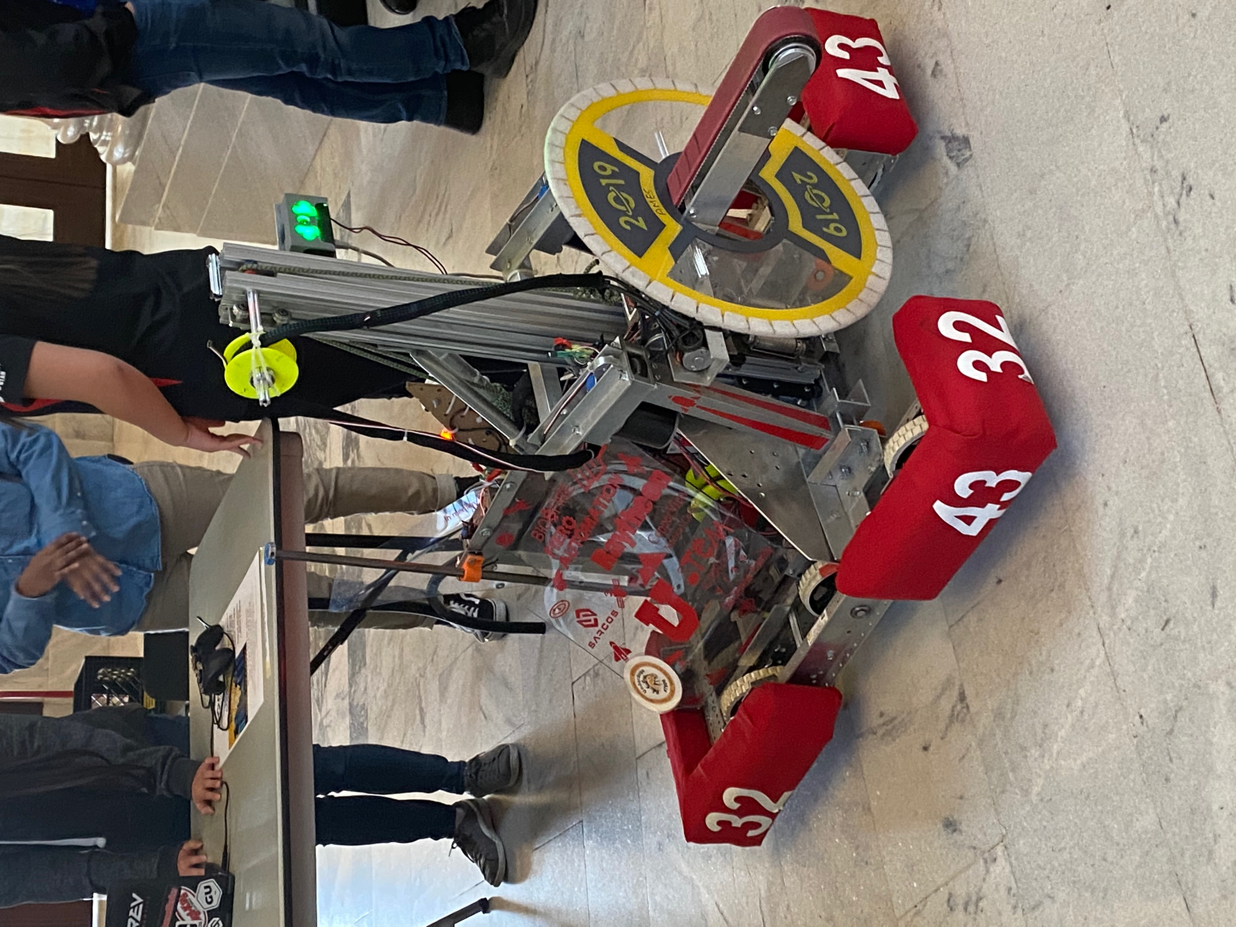

f
We are ½ way through the 2020 General Legislative Session!
House Social Media
Twitter: @utahhousereps
Facebook:
Utah House Republicans
Instagram: @utahreps
Federal Delegation Visits

