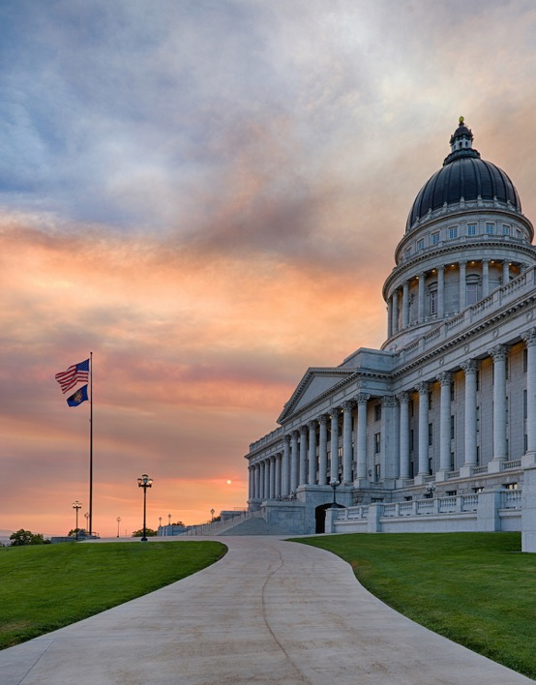
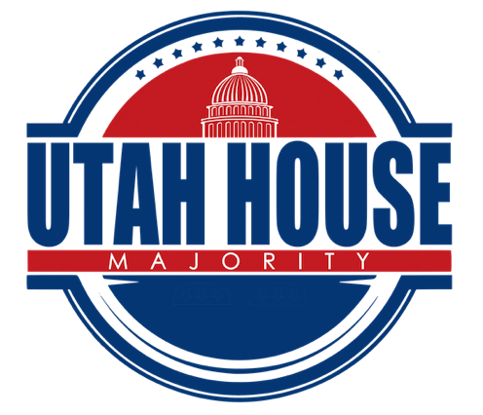

Page 6
My Legislation
Page 7
Events
Bills Passed
Page 4-5
Higher Education
Pol
Page 3
Week 3 Overview
Page 2
2020 LEGISLATIVE
Week 3


Week 3 Overview
150th Anniversary of Utah Granting Women the Right to Vote
2020 marks the 150th anniversary of Utah women being the first to vote in the nation. 2020 also marks the 100th anniversary of the 19th amendment, granting all women the right to vote in the United States. On Wednesday, February 12, the Legislature, along with 2,000+ students, organizations, and many volunteers celebrated this monumental event. Legislators wore yellow roses to honor women’s suffrage and passed HJR 12 Joint Resolution Celebrating Women’s Suffrage in Utah.

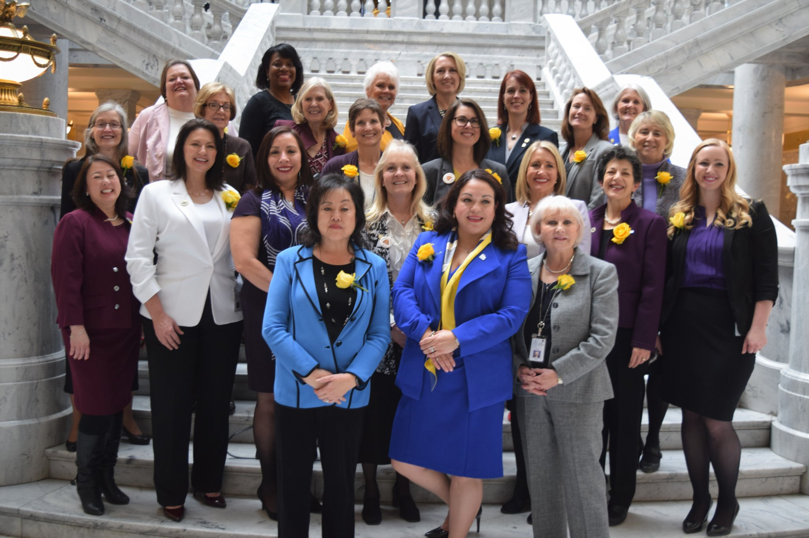

Thomas Wright Visits Caucus
Throughout the remainder of the session, our caucus will be visited by the Republican gubernatorial candidates. On Thursday, we were visited by Thomas Wright.

Fallen Soldiers
This week the House honored the families of fallen soldiers on the House floor. We are grateful for the sacrifice of all our soldiers and their families.

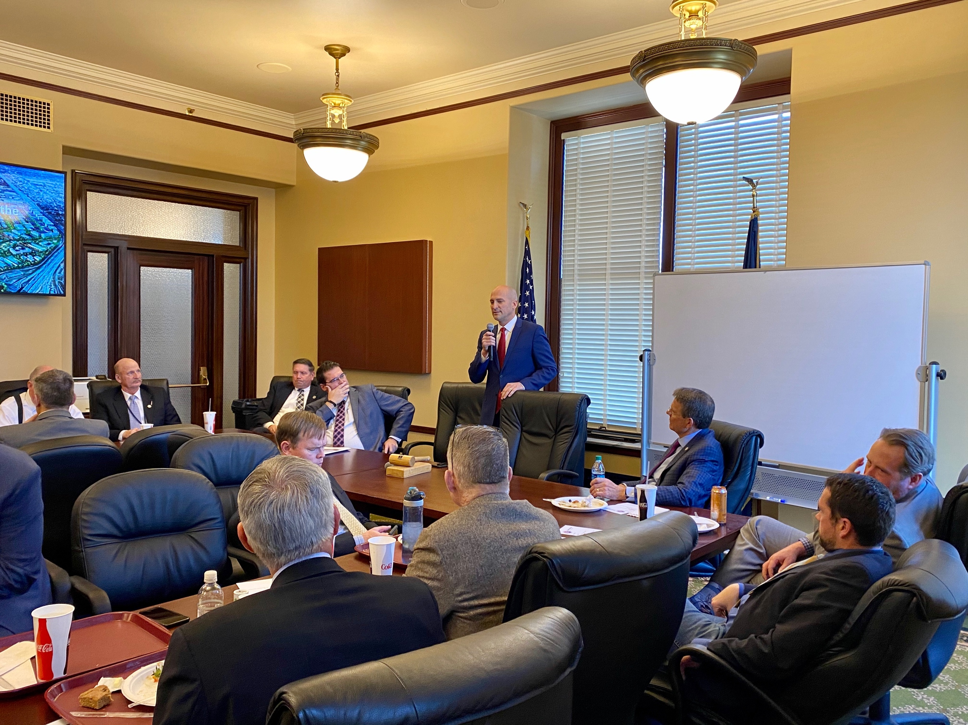

Page 2
Page 2

Week 3 Overview (cont.)

Higher Education
SB 111 Higher Education Amendments, sponsored by Speaker Brad Wilson and Senator Ann Millner, passed the Senate Education Committee this week. SB 111 will reinvent Utah’s postsecondary education governance structure. The Legislature is proposing to merge the Utah System of Higher Education (USHE) and the Utah System of Technical Colleges (UTECH) into a new board – the Utah Board of Higher Education.
SB 111 will do the following things:
- Increase access to and opportunities for postsecondary education for all Utahns.
- Create seamless education pathways for our students, from certificates to degrees.
- Improve coordination and collaboration between institutions leading to increased completion rates and a better overall experience for our students.
- Meet the needs of a growing population and a growing workforce in an affordable and accessible way.
A reformed, streamlined governance structure will help meet the needs of an ever changing and growing workforce and will inevitably create a better experience for our state’s students.

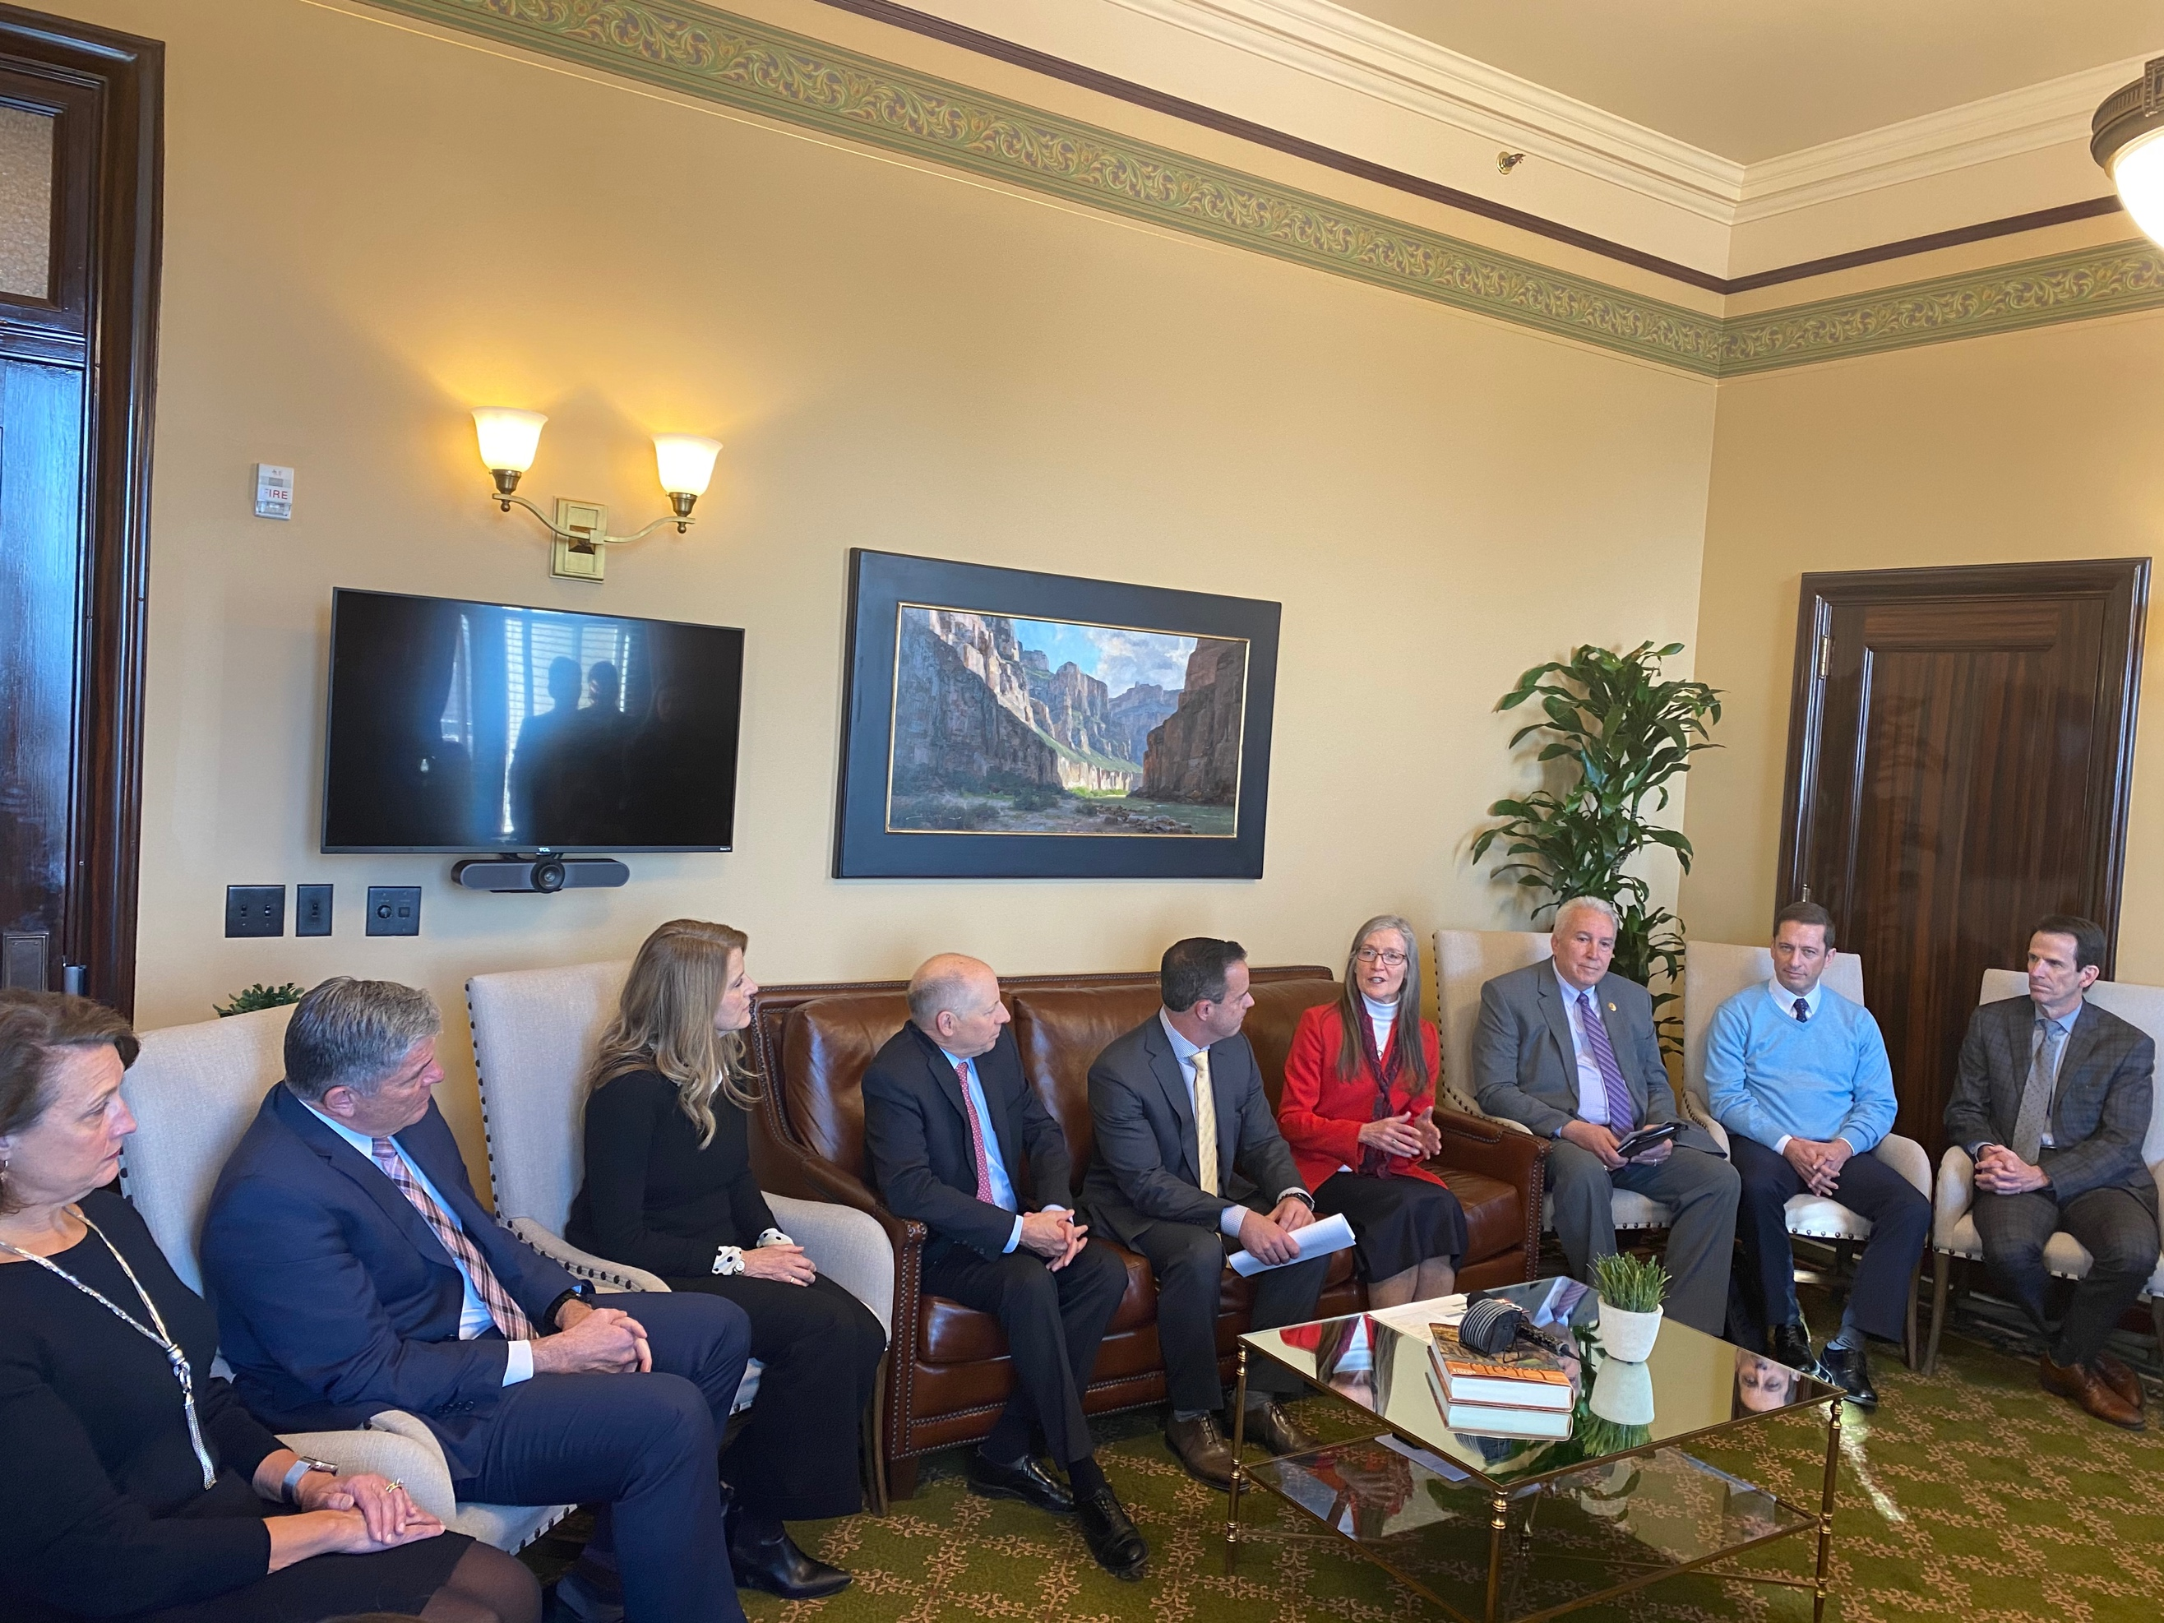

Page 2
Page 3

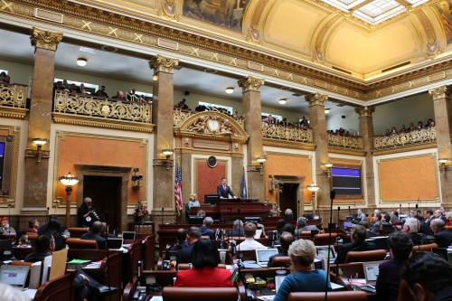
Page 4

Bills Passed by the House: Week 3
HB 148 Utah Recognizing Inspiring School Employees
HB 151 Traffic Safety Amendments
HB 160 Refugee Continuing Education Program
HB 164 Property Tax Notifications Amendments
HB 191 Dairy Commission Amendments
HB 17, 1st Sub Congressional Vacancies Amendments
HB 18, 1st Sub Industrial Hemp Program Amendments
HB 22 Utah Retirement Systems Amendments
HB 28 Legislative Water Development Commission Sunset Amendments
HB 35 Mental Health Treatment Access Amendments
HB 41 State Water Policy Amendments
HB 73 Interference with Public Servants Amendments
HB 84 Traffic Code Amendments
HB 86 Adult Autism Treatment Program
HB 102, 1st Sub Retaliation and Obstruction of Justice Amendments
HB 103 Utah Promise Scholarship Program Amendments
HB 110 Inmate Expenses Amendments
HB 113, 1st Sub Consumer Sales Practices Amendments
HB 119 Child Care Amendments
HB 125, 1st Sub Division of Wildlife Resources Amendments
HB 129 Natural Gas Amendments
HB 138 Transportation Corridor Preservation Amendments
HB 141 Educator Salary Incentive Program Amendments
HB 143 School Bus Safety Inspection Amendments
HB 165 Telephone and Facsimile Solicitation Act Amendments
HB 173 Firefighter Retirement Amendments
HB 177 Prescription Revisions
HB 188 Emergency Management Act Amendments
HB 196 Domestic Relations Debt
HB 199 Insured Homeowners Protection
HB 209 Health Data Authority Amendments
HB 218 State Government Cloud Computing Amendments
HB 237 Change to Effective Date of Water-related Amendments
SB 11 Offset for Occupational Health and Safety Related Donations Sunset Extension
HCR 3 Concurrent Resolution Encouraging Consideration of a Later Start Time for High School
HJR 1 Joint Resolution – United States Senate Vacancy
HJR 9 Joint Resolution Calling for an Application Ratings Board for Internet Ready Devices
Page 5

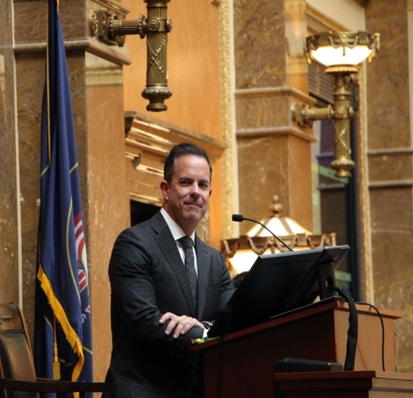
\
Bills Passed by the House: Week 3
HB 61 Amendments to County Form of Government
HJR 12 Joint Resolution Celebrating Women’s Suffrage in Utah
HB 234 Gestational Agreement Amendments
HB 180 Emissions Inspection Revisions
SB 26 Water Banking Amendments
SB 49, 1st Sub Aviation Amendments
HB 184, 1st Sub Municipal Regulation of Golf Carts
HB 99, 1st Sub Enhanced Kindergarten Amendments
HB 175, 1st Sub Education Accountability Amendments
HB 195, 1st Sub Identifying Wasteful Health Care Spending
HB 147, 1st Sub Division of Real Estate Amendments
HB 223, 1st Sub Statutes of Repose and Limitations Amendments
HB 97, 1st Sub Newborn Safe Haven Amendments
HJR 6 Joint Resolution on the Benefits of Therapy Animals
SB 15 Government Operations Sunset Reauthorizations
HB 221 Municipal Office and Local Elections
HB 163 Cultural Stewardship Amendments
HB 14, 2nd Sub School Absenteeism and Truancy Amendments
HCR 8 Concurrent Resolution Commending Successful Participation in the Municipal Alternative Voting Methods Pilot Program
HB 216 Organ Donation Preference
HB 34, 1st Sub Tanning for Minors
HB 114, 2nd Sub Early Learning Training and Assessment Amendments
HB 70 Repeal of Single-Mark Straight Ticket Voting
HB 128, 1st Sub License Plate Reading Technology Amendments
HCR 7, 1st Sub Concurrent Resolution Encouraging Congressional Action on Prescription Drug Prices

Page 6
Bill Title
Description of Bill
Bill Title
Description of Bill

Page 7
Library Day on the Hill
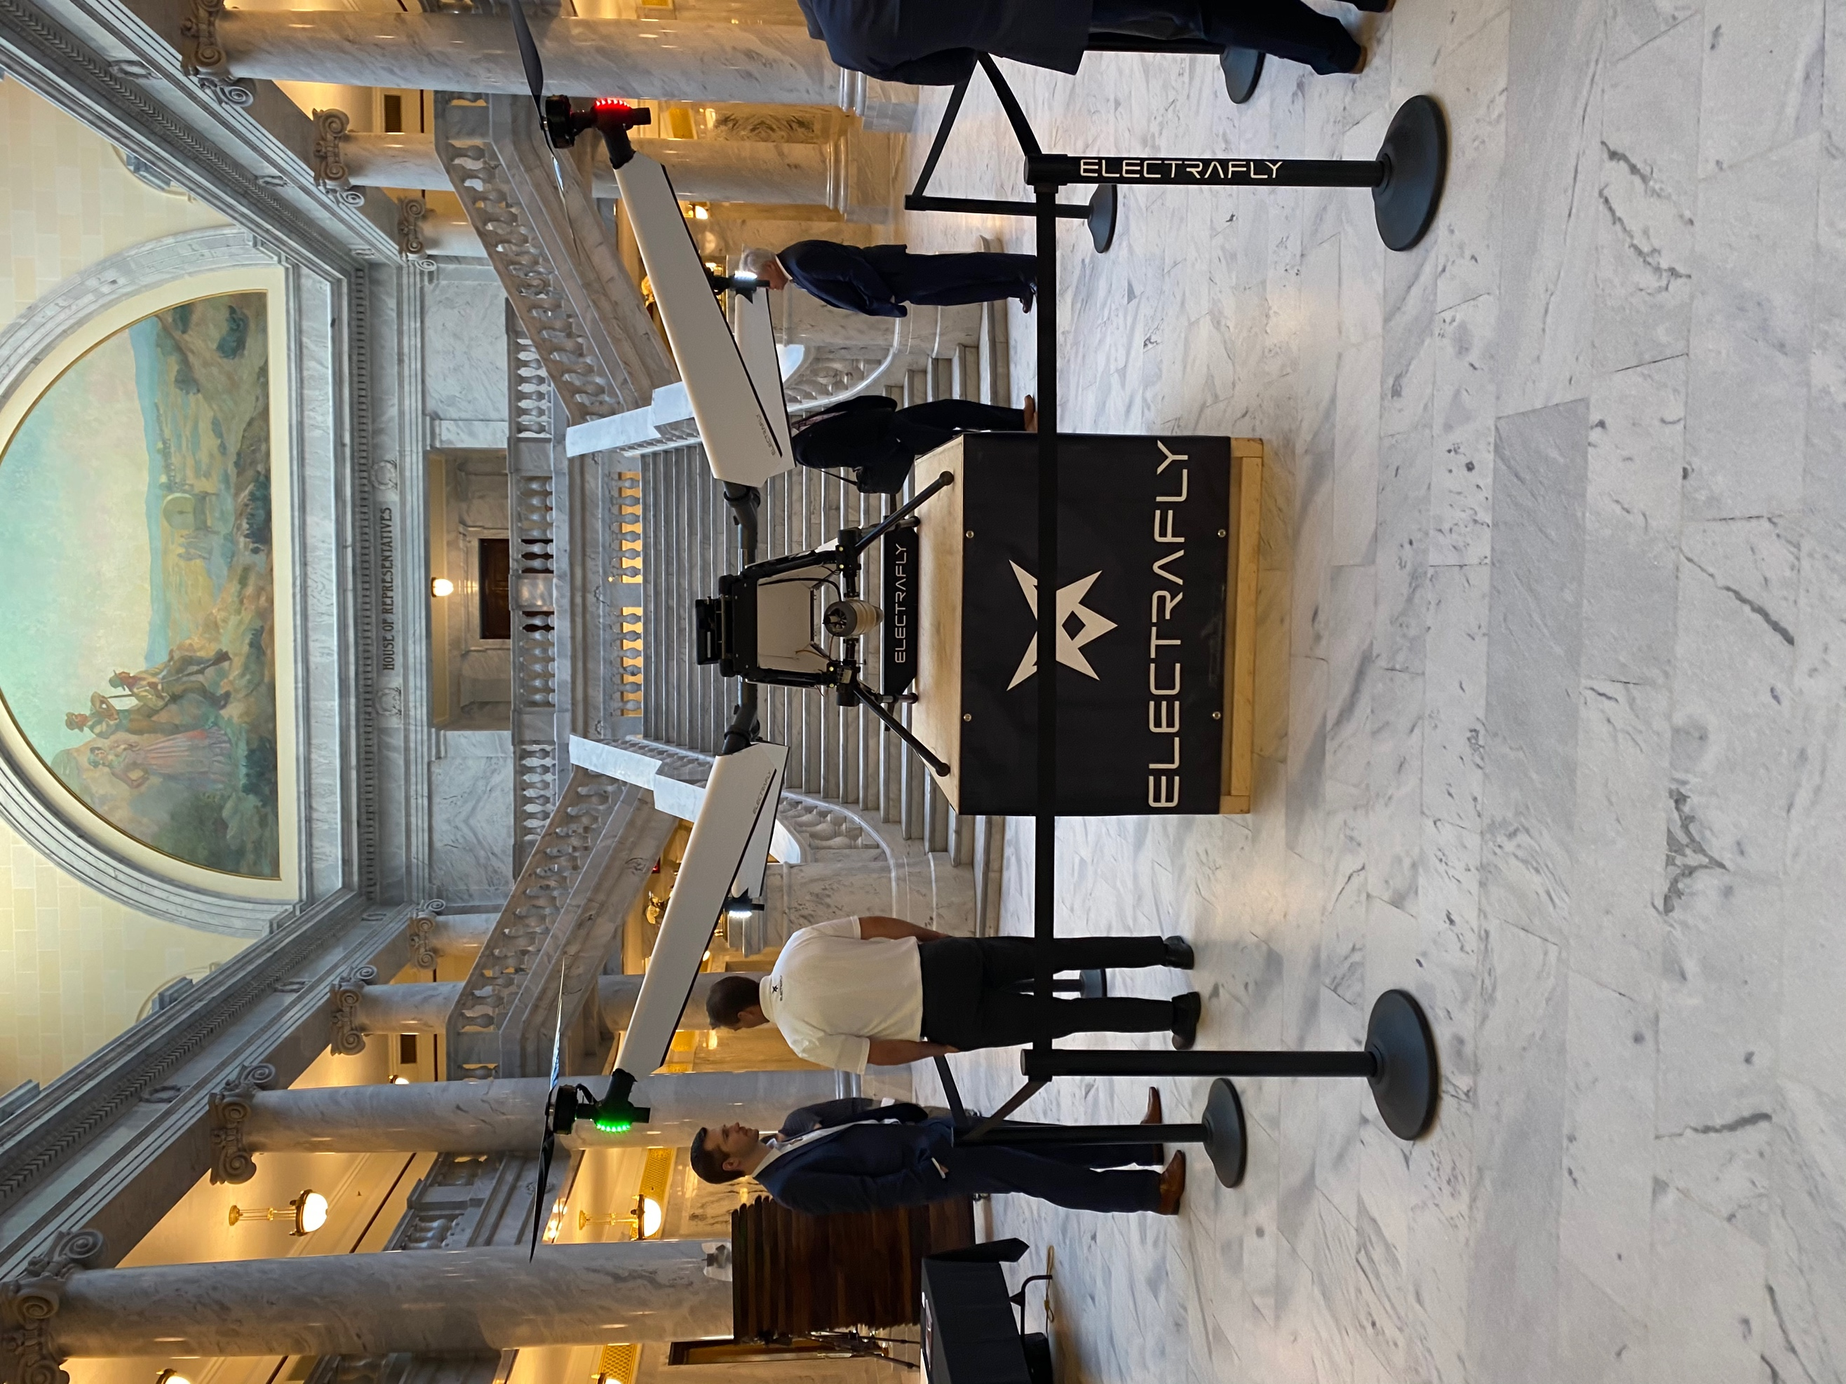

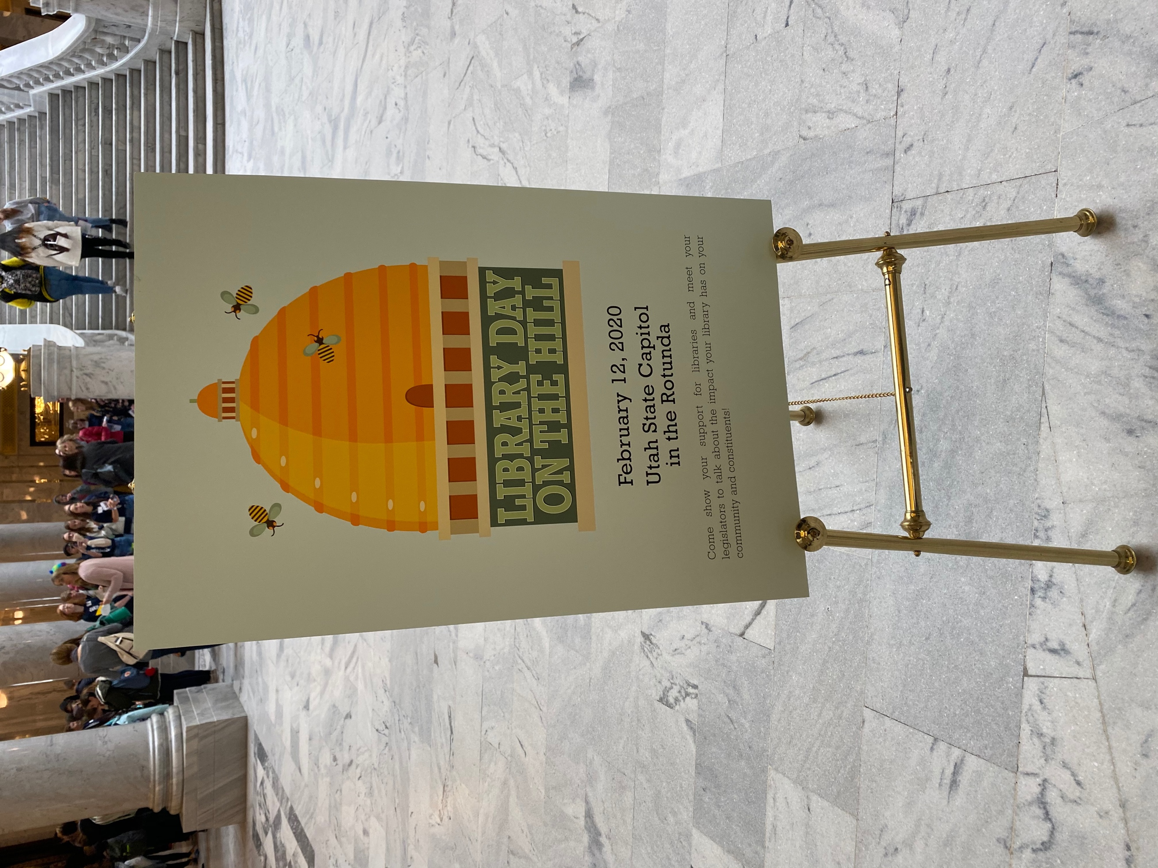

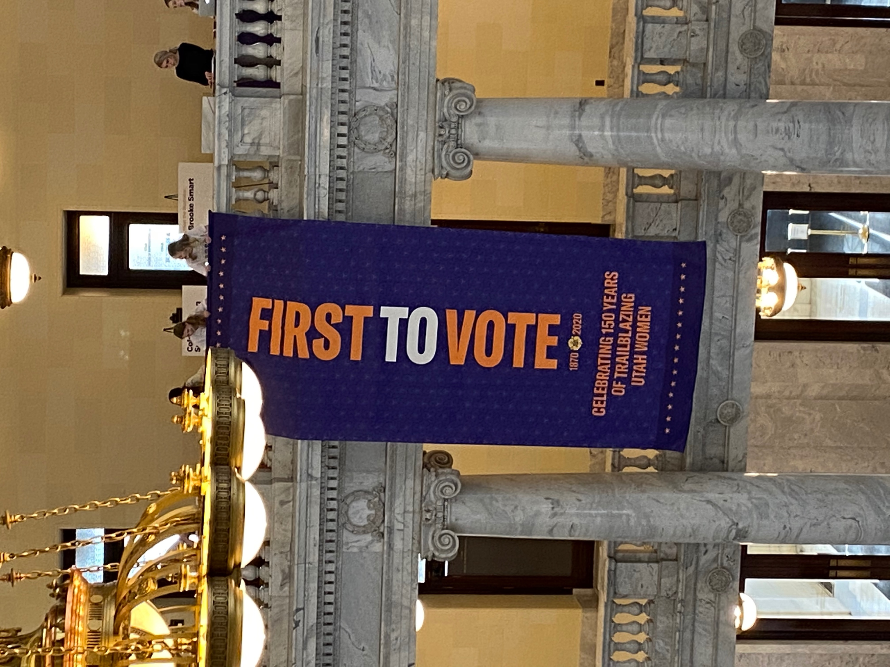
First to Vote Celebration
Technology Day on the Hill
House Social Media
Twitter: @utahhousereps
Facebook:
Utah House Republicans
Instagram: @utahreps
My Social Media
Twitter:
Facebook:
Instagram:

