Overview

Tax reform is about people. This proposal helps Utahns in three major ways:

- It gives money back to Utah families through an $80 million tax cut.
- It ensures we can keep paying for important things like education, roads, and health care.
- It preserves our outstanding quality of life and puts us on a path to successfully managing our state’s extraordinary growth.

Here are some of the highlights that help Utah individuals and families:

- It shifts higher education funding out of the education fund and into the general fund, holding public education harmless.
- It gives a Grocery Tax Credit to low-income and fixed-income families to offset a restored sales tax on food.
- It provides an Earned Income Tax Credit, creates a new income tax credit for Social Security retirement income, and increases the Utah Dependent Exemption.
- It addresses structural imbalances by increasing sales tax revenue by approximately $570 million and decreasing income tax revenue by $650 million.
  - This results in an overall net tax reduction of approximately $80 million.
  - A family of four making $60,000 would see an estimated tax reduction of more than $320 per year.


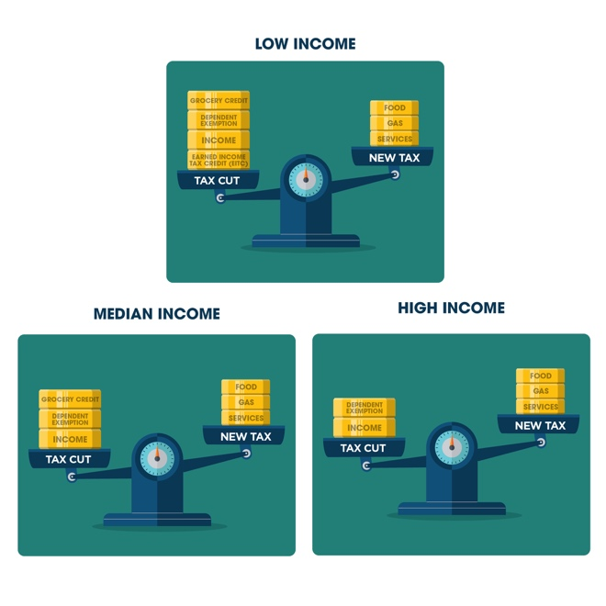
Tax Cut
How about an $80 million tax cut for hardworking Utah citizens. For the past several months, my colleagues on the Tax Restructuring and Equalization Task Force have been exploring the most effective ways to improve our tax system. The draft proposal they’re putting forward to the legislature is a balanced approach. Check it out

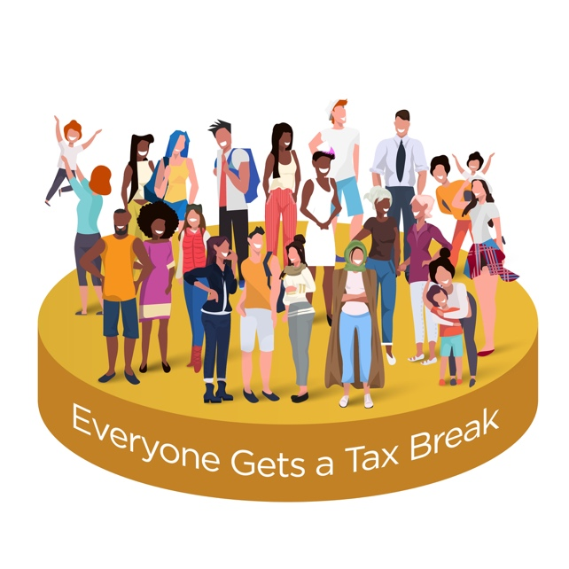
The tax reform proposal cuts government spending $80 million, all of which will go back into the pockets of Utah families.
During this summer’s statewide listening tour, Utah citizens were clear about their desire to reduce government spending. The Utah Legislature heard the people and have created a plan to do just that. Read the summary of the bill here:

The Utah Legislature what’s to put more money back in your pocket. A family of 4 making $60,000 will get to keep $320 of their hard-earned money with this new proposal.
Utahns work hard – we are working hard for you!

Pay checks are about to get bigger – we are reducing Utah’s income tax from 4.95-4.58!

Sales Tax on
Food

Making ends meet is hard – we know this, so we are giving a targeted food credit for low- and middle-income families.



It’s hard to get by on a fixed income – that’s why we provide a tax credit on Social Security.

Funding Transportation
Ever missed your kids’ soccer games because you were caught in traffic? We’ve all been there. We have too many transportation needs and not enough money. It’s important for all of us to pay for what they use. Tax reform will make sure we get home safer and quicker.
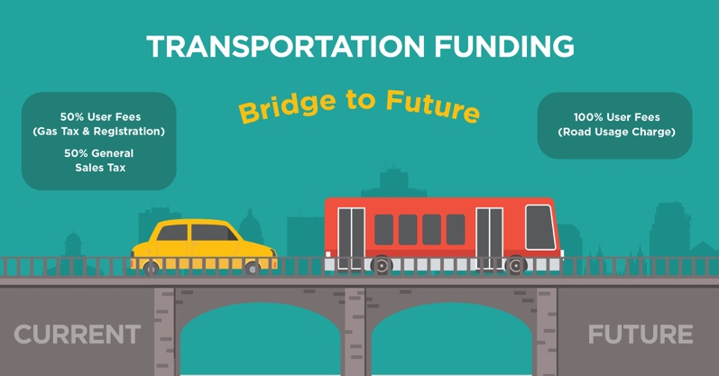

Credits and Exemptions
Exemptions that are currently given in Utah will now be heavily evaluated and must be justified. The tax proposal prevents unnecessary exemptions by reinstating a reporting requirement to ensure that exemptions in place moving forward continue to make sense within the new system.


The task force has proposed creating a sales tax exemption for feminine hygiene products.

The Process

As the tax task force continues to fine-tune a recommendation to present to the full legislature, there will be additional opportunities for public input. Meetings are scheduled for Thursday, November 7th and Thursday, November 21st. We encourage everyone to attend and participate in this process. You can submit comments, feedback, and suggestions online at www.strongerfutures.utah.gov.

Our goal all along has been to find the best tax policy structure to support our growing and changing economy. We look forward to hearing input from the public, so together we can implement a tax policy that will support our growing state and help us maintain the high quality of life we currently enjoy.
https://le.utah.gov/interim/2019/pdf/00002844.pdf

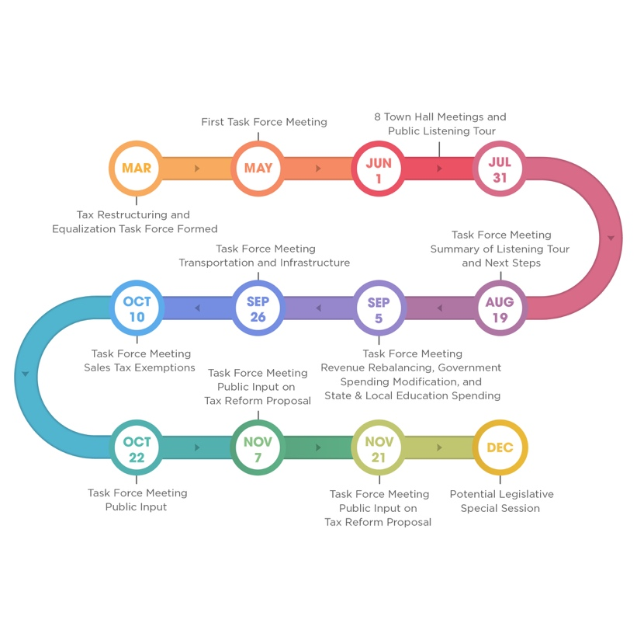

The task force has undertaken a thoughtful and thorough approach to tax reform. Extensive time and consideration took place in creating a policy that reduces taxes for all Utahns and addresses the changes in our growing economy.

Education

Providing the funding for our kids is the most important thing we do. Tax reform will make sure that in a changing economy our schools continue to get increased funding. Throughout the tax reform process, the legislature has prioritized the needs of Utah’s school children and will continue to do so.




Tax Cut

How about an $80 million tax cut for hardworking Utah citizens? #utleg #utpol #strongerfutures

The Utah Legislature what’s to put more money back in your pocket. A family of 4 making $60,000 will get to keep $320 of their hard-earned money with this new proposal.
Utahns work hard – we are working hard for you! #utleg #utpol #strongerfutures

The tax reform proposal cuts government spending $80 million, all of which will go back into the pockets of Utahns. Read the summary of the bill here: #utpol #utleg #strongerfutures

Pay checks are about to get bigger – we are reducing Utah’s income tax from 4.95-4.58!
#utleg #utpol #strongerfutures

Sales Tax on Food

Making ends meet is hard – we know this, so we are giving a targeted food credit for low- and middle-income families.
#utpol #utleg #strongerfutures

It’s hard to get by on a fixed income – that’s why we provide a tax credit on Social Security.
#utpol #utleg #strongerfutures

Funding Transportation
Ever missed your kids’ soccer games because you were caught in traffic? We’ve all been there. We have too many transportation needs and not enough money. It’s important for all of us to pay for what they use. Tax reform will make sure we get home safer and quicker.

Tax Credits and Exemptions

Exemptions that are currently given in Utah will now be evaluated and must be justified. The proposal prevents unnecessary exemptions by reinstating a reporting requirement to ensure that exemptions in place moving forward continue to make sense within the new system #utleg

The task force has proposed creating a sales tax exemption for feminine hygiene products.
#utpol #utleg #strongerfutures

Education
Providing funding for our kids is the most important thing we do. Tax reform will make sure that in a changing economy our schools get increased funding. Throughout the tax reform process, the legislature has prioritized the needs of Utah’s children and will continue to do so.

The Process
There will be additional opportunities for public feedback as the Tax Restructuring and Equalization Task Force continues to fine tune a recommendation to present to the full legislature.
(Thread) Meetings are scheduled for Thursday, November 7 and Thursday, November 21 and the Utah State Capitol. You can weigh in at www.strongerfutures.utah.gov. #utpol #utleg #strongerfutures

We encourage everyone to attend and participate in the tax reform process. Attend a meeting or submit comments, feedback, and suggestions online at www.strongerfutures.utah.gov. #utpol #utleg #strongerfutures

Throughout the tax reform process, the key focus has been, and continues to be, finding the best tax structure to support our growing and changing economy. #utpol #utleg #strongerfutures

The task force has undertaken a thoughtful and thorough approach to tax reform. Extensive time and consideration took place in creating a policy that reduces taxes for all Utahns and addresses the changes in our growing economy. #utpol #utleg #strongerfutures

As we move forward on the path to tax restructuring, we continue to seek input from the public so that together we can create a tax policy that will support our growing state and preserve the high quality of life we enjoy here in Utah.
#utpol #utleg #strongerfutures



Tax Cut
How about an $80 million tax cut for hardworking Utah citizens. For the past several months, my colleagues on the Tax Restructuring and Equalization Task Force have been exploring the most effective ways to improve our tax system. The draft proposal they’re putting forward to the legislature is a balanced approach. Check it out

The Utah Legislature what’s to put more money back in your pocket. A family of 4 making $60,000 will get to keep $320 of their hard-earned money with this new proposal.
Utahns work hard – we are working hard for you!

Pay checks are about to get bigger – we are reducing Utah’s income tax from 4.95-4.58!

The tax reform proposal cuts government spending $80 million, all of which will go back into the pockets of Utah families.
During this summer’s statewide listening tour, Utah citizens were clear about their desire to reduce government spending. The Utah Legislature heard the people and have created a plan to do just that. Read the summary of the bill here:

Sales Tax on Food

Making ends meet is hard – we know this, so we are giving a targeted food credit for low- and middle-income families.

It’s hard to get by on a fixed income – that’s why we provide a tax credit on Social Security.

Funding Transportation
Ever missed your kids’ soccer games because you were caught in traffic? We’ve all been there. We have too many transportation needs and not enough money. It’s important for all of us to pay for what they use. Tax reform will make sure we get home safer and quicker

Credits and Exemptions
Exemptions that are currently given in Utah will now be heavily evaluated and must be justified. The tax proposal prevents unnecessary exemptions by reinstating a reporting requirement to ensure that exemptions in place moving forward continue to make sense within the new system.

The task force has proposed creating a sales tax exemption for feminine hygiene products.

The Process
As the tax task force continues to fine-tune a recommendation to present to the full legislature, there will be additional opportunities for public input. Meetings are scheduled for Thursday, November 7th and Thursday, November 21st. We encourage everyone to attend and participate in this process. You can submit comments, feedback, and suggestions online at www.strongerfutures.utah.gov.

Our goal all along has been to find the best tax policy structure to support our growing and changing economy. We look forward to hearing input from the public, so together we can implement a tax policy that will support our growing state and help us maintain the high quality of life we currently enjoy. https://le.utah.gov/interim/2019/pdf/00002844.pdf

The task force has undertaken a thoughtful and thorough approach to tax reform. Extensive time and consideration took place in creating a policy that reduces taxes for all Utahns and addresses the changes in our growing economy.

Education

Providing the funding for our kids is the most important thing we do. Tax reform will make sure that in a changing economy our schools continue to get increased funding. Throughout the tax reform process, the legislature has prioritized the needs of Utah’s school children and will continue to do so.

